Engineering Multiscale Porosity and Adsorption Thermodynamics in PAN–Silica Hybrid Nanocomposites: Linking Sol–Gel Synthesis with Surface Energy Heterogeneity

Khamdam Akbarov*¹, Nuritdin Kattaev¹, Jaykhun Mamatov¹,
Khayrulla Mirzakhidov¹, Vladimir Kolyadin¹, Yong-Ill Lee²

¹Faculty of Chemistry, National University of Uzbekistan named after Mirzo Ulugbek, Tashkent 1001744, Uzbekistan, ²Anastro Laboratory, Department of Chemistry, Changwon National University, Changwon 51140, Republic of Korea *https://orcid.org/0000-0002-3225-2427

ABSTRACT
This study establishes the relationship between synthesis conditions, multiscale pore architecture, and adsorption thermodynamics in PAN–SiO₂ hybrid nanocomposites prepared via sol–gel routes. Based on adsorption isotherms of benzene, water, and nitrogen analyzed using BET, V–t, BJH, DFT, and the Theory of Volume Filling of Micropores (TVFM), a hierarchical micro–mesoporous structure was identified, with a specific surface area up to 236 m²/g and a total pore volume approaching 1.0 cm³/g, where micropores contribute up to ~95% of the total pore volume.
An optimal composition (PAN–SiO₂ ≈ 1:3) was found to provide maximum pore development due to the formation of interpenetrating polymer–inorganic networks. Water adsorption reaches 3.79 mmol/g, significantly exceeding benzene adsorption (~0.99 mmol/g), indicating the dominance of specific interactions such as hydrogen bonding. Thermodynamic analysis reveals pronounced surface energy heterogeneity, with differential heats of adsorption up to 110 kJ/mol (water) and 98.5 kJ/mol (benzene), and strongly negative entropy values (down to −147 J/mol·K), reflecting restricted molecular mobility within the pore structure.
The adsorption behavior follows a multistage mechanism involving micropore filling, cooperative interactions (for water), and capillary condensation. The results demonstrate that both pore structure and surface energetics can be effectively tuned through synthesis, highlighting the potential of PAN–SiO₂ hybrid nanocomposites for advanced adsorption and separation applications.
Keywords: PAN–SiO₂, sol–gel, hierarchical porosity, adsorption, TVFM, thermodynamics

I. INTRODUCTION
Organic–inorganic hybrid materials have attracted significant attention due to their ability to combine the advantages of polymeric and inorganic systems, enabling control over structure and functionality at the nano- and mesoscale. Among these materials, silica-based hybrids synthesized via the sol–gel process are particularly promising due to their high chemical stability, tunable pore structure, and developed surface area [1–3].
Polyacrylonitrile (PAN) is an attractive polymer matrix owing to the presence of polar nitrile groups (–C≡N), which can interact with silanol groups (–Si–OH) on silica surfaces. These interactions lead to the formation of interpenetrating polymer–inorganic networks (IPN), which significantly influence pore structure, adsorption behavior, and thermodynamic properties [4–6].
A key challenge is to establish quantitative relationships between synthesis conditions, pore structure, and adsorption mechanisms. The adsorption behavior of hybrid materials is governed not only by geometric characteristics (surface area, pore size distribution) but also by surface energetics and the nature of adsorbates [2,7].
To address this, a comprehensive approach combining adsorption isotherms, thermodynamic analysis, and modeling is required. Classical methods such as BET, BJH, and V–t analysis provide information on pore structure, while modern approaches such as DFT and TVFM enable a deeper understanding of adsorption mechanisms and energy distribution [8–10].
In this work, the relationship between synthesis, structure, and adsorption thermodynamics in PAN–SiO₂ hybrid nanocomposites is investigated using benzene, water, and nitrogen adsorption. Particular attention is given to the interplay between pore architecture and surface energetics, which determines adsorption performance.
II. METHODOLOGY
2.1. Materials
Polyacrylonitrile (PAN) was used as the organic component, including powdered PAN and PAN-based fibers (“Nitron”). Tetraethoxysilane (TEOS) was used as the silica precursor and purified by fractional distillation. N,N-dimethylformamide (DMF) was used as the solvent, and glycerol was introduced as a structure-directing agent. Acidic (HCl) and basic (NH₄OH) catalysts were used to control hydrolysis–condensation kinetics [11].
2.2. Synthesis
PAN–SiO₂ hybrid nanocomposites were synthesized via a sol–gel approach combined with polymer incorporation strategies. A homogeneous PAN solution (5 wt.%) was prepared in DMF, followed by the addition of TEOS and glycerol. The mixture was homogenized using ultrasonic treatment (25 kHz, 3 min, 293 K), producing a stable sol that underwent hydrolysis and polycondensation under ambient conditions.
The sol–gel process involves hydrolysis of alkoxysilane groups followed by condensation into a three-dimensional siloxane network, accompanied by nucleation and growth of silica clusters with characteristic pore sizes in the nanometer range (1–10 nm). The presence of PAN promotes the formation of interpenetrating polymer networks (IPN), which govern the final pore architecture and surface properties.
Such synthesis strategies are consistent with established approaches for preparing organic–inorganic hybrid materials with hierarchical porosity and controlled nanostructure [12].
2.3. Adsorption Measurements
Adsorption properties were investigated using benzene and water vapors as model nonpolar and polar adsorbates, respectively, and nitrogen at 77 K for pore structure characterization. Prior to measurements, samples were degassed under vacuum for 10–12 hours.
Nitrogen adsorption–desorption isotherms were recorded at 77.35 K under high vacuum (~6.58 × 10⁻⁵ Torr). Adsorption measurements were carried out using a volumetric high-vacuum system coupled with a differential microcalorimeter, enabling simultaneous determination of adsorption isotherms and differential heats.
Such combined adsorption–calorimetric techniques are widely recognized as reliable tools for investigating adsorption thermodynamics and surface heterogeneity [13].
2.4. Structural Analysis
The porous structure was analyzed using complementary adsorption-based methods. The specific surface area was determined using the multipoint BET method in the relative pressure range of 0.05–0.30. The V–t method was used to separate microporous and external surface contributions, while the BJH method was applied to evaluate mesopore size distribution.
Additionally, Density Functional Theory (DFT) was employed to obtain an accurate description of pore size distribution in the micro–mesopore range. The combined use of BET, BJH, and DFT methods is recommended by IUPAC for the characterization of hierarchical porous materials [9,14].
2.5. Thermodynamic Analysis
Thermodynamic parameters were determined from adsorption isotherms and calorimetric measurements. The Gibbs free energy was calculated from equilibrium data, while differential heats of adsorption were obtained directly from calorimetric measurements.
The differential entropy of adsorption was evaluated using the Gibbs–Helmholtz relationship, providing insight into molecular ordering and mobility within the pore structure. Such analysis is essential for understanding adsorption mechanisms and distinguishing between physical and specific adsorption [13,15].
2.6. Adsorption Modeling
The adsorption behavior was described using a three-term equation based on the theory of volume filling of micropores (TVFM), which accounts for surface heterogeneity and multiple adsorption domains. Model parameters were obtained by fitting experimental isotherms.
Multi-parameter adsorption models are widely used to describe heterogeneous porous systems and energy distributions in hybrid nanocomposites [16].
2.7. Kinetic Analysis
The kinetics of adsorption were evaluated by monitoring the time required to reach equilibrium as a function of adsorbate uptake. The adsorption process exhibited a multistage character governed by diffusion and surface interactions. At low coverage, adsorption is controlled by high-energy active sites, while at higher coverage, cluster formation and pore filling accelerate the process. Such behaviour is typical for hierarchical porous materials [11].

III. RESULTS
3.1. Gelation Behaviour and Structural Evolution
The formation of PAN–SiO₂ hybrid nanocomposites is governed by the coupled kinetics of hydrolysis and condensation of TEOS and the spatial constraints imposed by polymer chains. The gelation time decreased significantly with increasing TEOS content, indicating an increase in the rate of siloxane network formation. Conversely, increasing the PAN fraction resulted in a measurable delay in gelation, confirming that polymer chains hinder cluster–cluster interactions through steric shielding.
The transition from sol to gel occurred within a relatively narrow time window, depending on composition, with faster gelation observed at higher inorganic content. The critical composition at PAN:SiO₂ ≈ 1:3 corresponds to a balance between crosslinking density and polymer mobility, enabling the formation of a percolated but non-densified structure.
This regime is associated with the formation of interpenetrating polymer networks (IPNs), in which the inorganic silica framework provides structural rigidity, while PAN chains prevent excessive shrinkage and pore collapse. Such structural organization is essential for achieving high pore accessibility and uniform pore distribution.
The obtained micrographs reveal a highly heterogeneous, porous structure composed of aggregated nanoscale domains that form a continuous network (figure 1). The surface exhibits a rough topology with irregularly distributed clusters and interparticle voids, indicating the formation of a loosely packed, highly accessible porous framework [17].
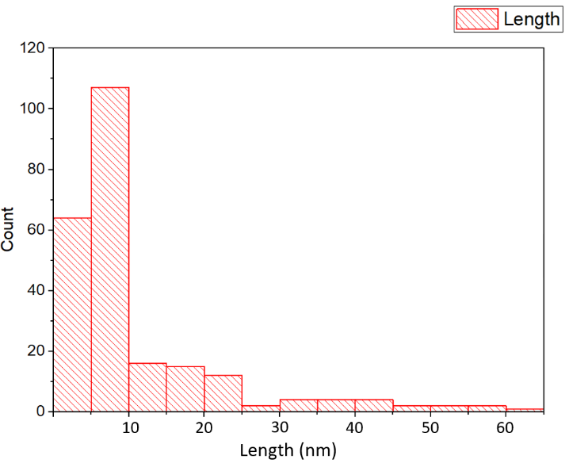
b
a
a
a
Figure 1. (a) SEM micrograph of PAN–SiO₂ hybrid nanocomposite; (b) particle size distribution obtained from SEM image analysis.

The observed morphology suggests that the sol–gel process in the presence of PAN forms a fractal-like structure, in which primary silica particles are interconnected via polymer-mediated interactions. Such aggregation behavior is characteristic of hybrid systems formed via simultaneous inorganic condensation and organic phase incorporation, resulting in hierarchical structuring across multiple length scales.
The absence of dense, compact regions confirms that the incorporation of PAN effectively suppresses excessive silica densification, which is consistent with the previously observed optimal porosity at intermediate compositions. The formation of interconnected aggregates provides both high surface area and open diffusion pathways, which are critical for adsorption processes.
The particle size distribution derived from image analysis shows a strongly skewed profile, indicating a non-uniform size distribution characteristic of aggregation-driven growth mechanisms. The majority of particles are concentrated in the 5–10 nm range, with a pronounced maximum around 6–8 nm, while a smaller fraction extends to larger sizes up to 60 nm.
This distribution suggests that the primary building units of the structure are nanosized particles that subsequently aggregate into larger clusters. The presence of a long tail toward larger sizes reflects secondary aggregation processes and cluster–cluster interactions.
Such a distribution is typical for sol–gel-derived systems, where nucleation produces small primary particles followed by diffusion-limited aggregation. The dominance of nanoscale particles confirms the formation of a highly dispersed structure, which is consistent with the high micropore contribution (~95%) observed in adsorption measurements.
3.2. Benzene Adsorption: Quantitative Analysis of Pore Accessibility
The benzene adsorption isotherms of the investigated samples exhibit a characteristic S-shaped profile, corresponding to type II isotherms, which indicates multilayer adsorption on heterogeneous surfaces and confirms the applicability of the BET model for quantitative analysis of the capillary–porous structure (figure 2).

Figure 2. Benzene adsorption isotherms of PAN–SiO₂ hybrid nanocomposites

A systematic increase in adsorption capacity is observed with increasing silica content in the composite. The lowest adsorption is observed for pristine PAN (X_{m} = 0.0027 g/g; S_BET = 6.36 m²/g), whereas pure silica exhibits significantly higher values (X_{m} = 0.0066 g/g; S_{BET} = 15.54 m²/g). Hybrid systems show intermediate but strongly composition-dependent behavior (table 1).
A pronounced structural effect is observed at the composition PAN:SiO₂ = 1:3, where the adsorption capacity reaches a maximum value of X_{m} = 0.0085 g/g and the specific surface area increases to 20.01 m²/g, exceeding not only the polymer but also the silica reference. This behavior indicates that pore development in hybrid systems is not a linear combination of components, but rather a result of cooperative structural organization [18].
The pore volume and structure are also significantly modified. The average pore radius (r_{avg}) increases from 50.31 Å (PAN) and 202.70 Å (silica) to 186.01 Å in the PAN:SiO₂ = 1:3 system, indicating the formation of a distinct pore architecture. Importantly, this composition also exhibits the highest values of thermodynamic parameters ($-∆g_{m}^{\text{max}}$ = 2.47 J/mol; −ΔGᵢ = 2.30 J/mol), confirming enhanced interaction between adsorbate and adsorbent.

Table 1.
Textural parameters derived from benzene vapor adsorption
№ | Sample | Xₘ (g/g) | r_{avg} (Å) | S_{BET} (m²/g) | $$-∆g_{m}^{\text{max}}$$  (J/mol) | −ΔGᵢ  (J/mol)
1 | PAN | 0.0027 | 50.31 | 6.36 | 0.81 | 0.84
2 | SiO₂ | 0.0066 | 202.70 | 15.54 | 2.25 | 2.81
3 | PAN–SiO₂ (1:1) | 0.0044 | 136.68 | 10.36 | 0.69 | 0.75
4 | PAN–SiO₂ (1:2) | 0.0058 | 103.74 | 13.65 | 1.07 | 1.17
5 | PAN–SiO₂ (1:3) | 0.0085 | 186.01 | 20.01 | 2.47 | 2.30
6 | PAN–SiO₂ (1:4) | 0.0080 | 128.52 | 18.83 | 1.75 | 1.95
7 | SiO₂ + 2 wt.% PAN | 0.0060 | 108.36 | 14.12 | 1.42 | 1.51

At higher silica content (1:4), a decrease in X_{m} (to 0.0080 g/g) and S_{BET} (to 18.83 m²/g) is observed, suggesting partial densification or reduced accessibility of the pore structure. This indicates that excessive inorganic content leads to increased rigidity of the matrix and limits the development of an open porous network.
The superior performance of the PAN:SiO₂ = 1:3 system is attributed to the formation of interpenetrating polymer–inorganic networks, in which the silica phase provides structural rigidity while the polymer phase prevents pore collapse and ensures connectivity. This leads to an optimal combination of pore size, accessibility, and structural stability.
Furthermore, comparison with samples prepared by impregnation (SiO₂ + 2% PAN) shows that sol–gel-derived materials exhibit higher adsorption capacity and better-developed pore structure, confirming the effectiveness of the sol–gel method for generating hybrid porous systems.
3.3. Water Adsorption: Quantitative Evidence of Surface Functionality
The adsorption of water vapor exhibits fundamentally different behavior compared to benzene, reflecting the dominant role of specific interactions and surface chemistry. Unlike benzene, where a sharp increase in adsorption occurs at P/P₀ ≈ 0.5, water adsorption shows a steep rise only at relative pressures close to saturation (P/P₀ → 1), indicating a different adsorption mechanism (figure 3).

Figure 3. Water adsorption isotherms of PAN–SiO₂ hybrid nanocomposites
The overall trends in adsorption are similar to those observed for benzene, with the PAN:SiO₂ = 1:3 composition again demonstrating the highest adsorption capacity. In this case, the monolayer capacity reaches X_{m} = 0.0097 g/g, and the specific surface area increases to 34.07 m²/g, significantly exceeding the corresponding values obtained from benzene adsorption (table 2).
A substantial increase in thermodynamic parameters is also observed. The Gibbs free energy reaches $-∆g_{m}^{\text{max}}$ = 6.32 J/mol and −ΔGᵢ = 7.40 J/mol, which is significantly higher than the corresponding values for benzene adsorption. This confirms the stronger interaction between water molecules and the hybrid surface.

Table 2.
Textural parameters derived from water vapor adsorption
№ | Sample | Xₘ (g/g) | r_{avg} (Å) | S_{BET} (m²/g) | $$-∆g_{m}^{\text{max}}$$  (J/mol) | −ΔGᵢ  (J/mol)
1 | PAN | 0.0059 | 18.34 | 2.72 | 2.19 | 2.22
2 | SiO₂ | 0.0045 | 217.72 | 15.80 | 4.98 | 5.80
3 | PAN–SiO₂ (1:1) | 0.0024 | 163.70 | 8.43 | 4.11 | 4.36
4 | PAN–SiO₂ (1:2) | 0.0025 | 182.23 | 8.78 | 4.27 | 4.65
5 | PAN–SiO₂ (1:3) | 0.0097 | 111.54 | 34.07 | 6.32 | 7.40
6 | PAN–SiO₂ (1:4) | 0.0041 | 108.33 | 14.40 | 3.16 | 3.40
7 | SiO₂ + 2 wt.% PAN | 0.0060 | 42.71 | 21.07 | 3.58 | 3.75

The pore structure parameters show notable differences compared to benzene adsorption. While silica exhibits a large average pore radius (~217 Å), the hybrid systems display optimized pore sizes (111–182 Å), with the PAN:SiO₂ = 1:3 composition again showing the most favorable balance between pore size and surface area.
An important observation is that water adsorption on PAN and PAN-modified silica is significantly higher than that observed for benzene, despite lower BET surface areas in some cases. This indicates that adsorption is not solely controlled by geometric parameters, but also by the presence of hydrophilic active sites.
This behavior can be explained by several factors. First, the smaller kinetic diameter of water molecules allows them to penetrate narrower pores that are inaccessible to benzene. Second, the presence of hydrophilic functional groups promotes strong adsorption via hydrogen bonding. Third, structural effects such as swelling and pore merging may occur in hydrophilic regions, leading to an apparent increase in accessible pore volume.
The non-monotonic dependence of structural parameters on composition is also evident. While increasing silica content generally enhances adsorption, the maximum is observed at PAN:SiO₂ = 1:3, after which further increase leads to a decrease in performance. This is attributed to increased rigidity of the silica framework, which limits structural flexibility and reduces effective pore accessibility.
As in the case of benzene adsorption, materials obtained by the sol–gel method significantly outperform those prepared by impregnation. This confirms that controlled formation of hybrid networks during synthesis is critical for achieving optimal pore structure and adsorption performance.
Overall, the results demonstrate that water adsorption in PAN–SiO₂ hybrid nanocomposites is governed by a combination of structural and energetic factors, with optimal performance achieved at compositions that balance pore accessibility, surface functionality, and structural flexibility.
3.4. Nitrogen Adsorption: Quantitative Analysis of Pore Structure
The pore structure of PAN–SiO₂ hybrid nanocomposites was comprehensively investigated using nitrogen adsorption–desorption isotherms measured at 77.35 K, which is widely recognized as a standard method for quantitative characterization of porous materials. The obtained isotherms exhibit a characteristic S-shaped profile corresponding to type II behavior, indicating the coexistence of monolayer–multilayer adsorption and capillary condensation processes (figure 4). A pronounced hysteresis loop between adsorption and desorption branches is observed for all studied samples, which confirms the presence of a developed capillary–porous structure and reflects delayed evaporation of condensed nitrogen within the pore system.
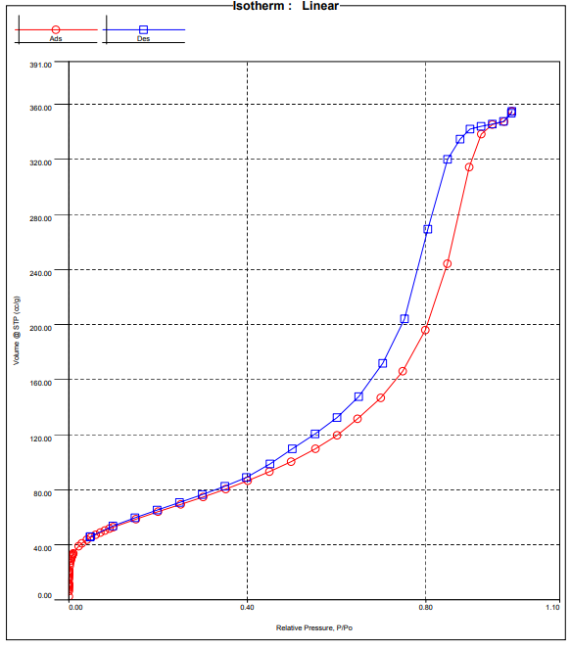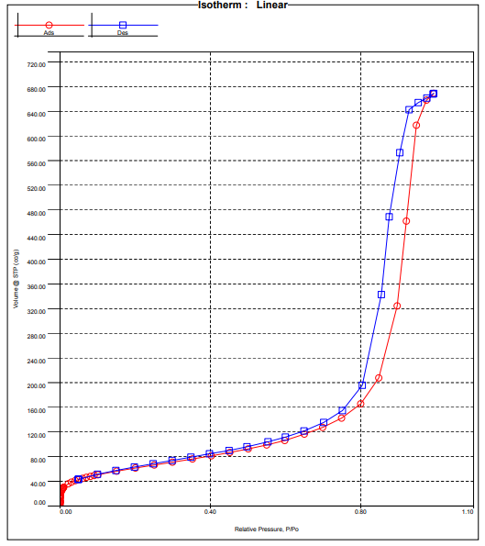
b
a
Figure 4. N₂ adsorption–desorption isotherms at 77 K for PAN–SiO₂ hybrid nanocomposites with ratios (a) 1:2 and (b) 2:1.

Although the overall shape of the isotherms remains similar for different compositions, significant quantitative differences are observed depending on the PAN:SiO₂ ratio. In particular, the sample with a composition of PAN–SiO₂ = 1:2 is characterized by a higher total pore volume, whereas the PAN–SiO₂ = 2:1 system demonstrates a larger external surface area. These differences indicate that the variation of composition leads not only to quantitative changes in porosity but also to qualitative restructuring of the pore network.
The multipoint BET analysis performed in the relative pressure range of 0.05–0.35 shows excellent linearity, with correlation coefficients approaching unity (r² ≈ 0.99999), confirming the applicability of the model (figure 5). The calculated specific surface areas reach 236.51 m²/g for the PAN–SiO₂ = 1:2 sample and 225.11 m²/g for the 2:1 composition, while the BET constant C lies in the range of 65.20–66.23, indicating relatively strong adsorbent–adsorbate interactions. Notably, the shift of the BET linear region toward lower relative pressures suggests a significant contribution of micropores to the overall structure [19].
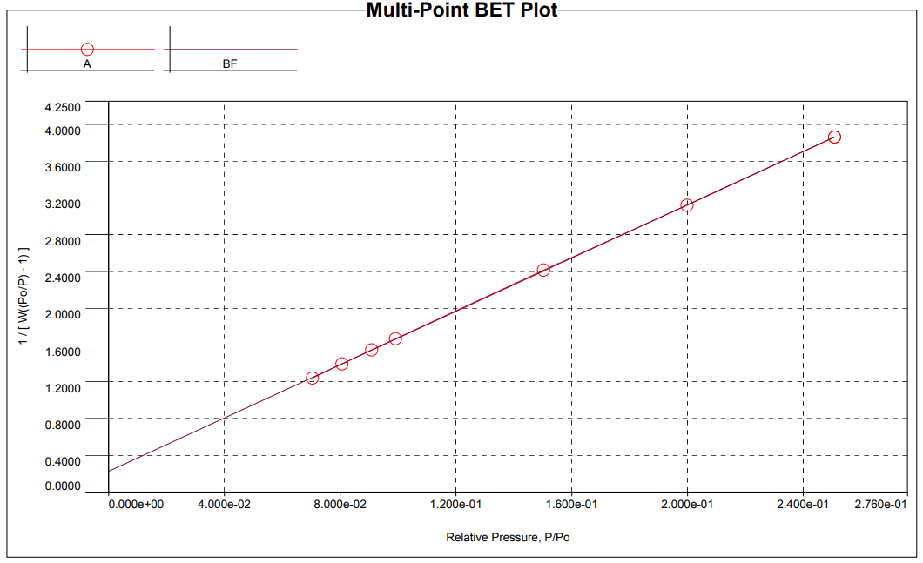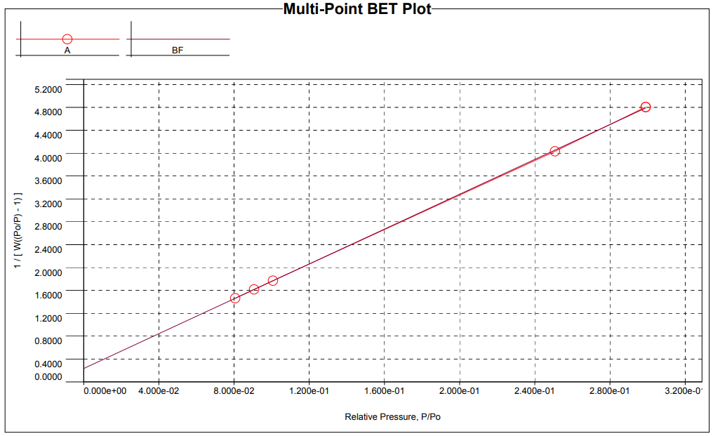
c
a
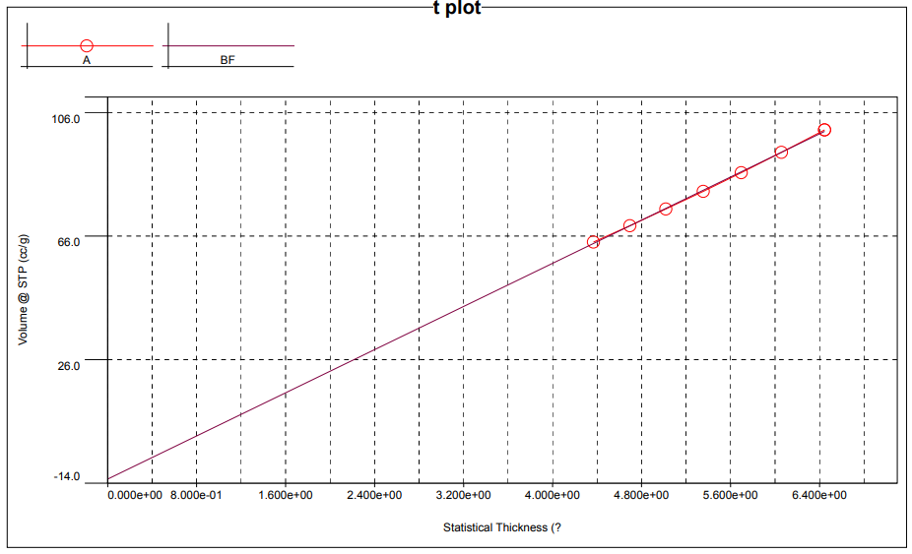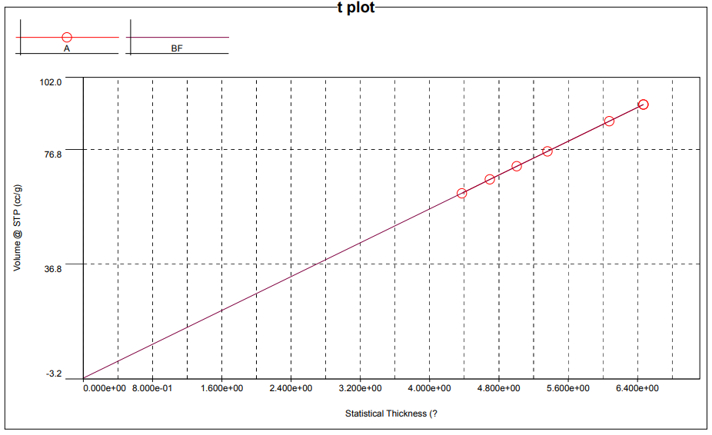
d
b
Figure 5. Linearized BET plots and t-plot analysis for PAN–SiO₂ hybrid nanocomposites at compositions 1:2 (a, c) and 2:1 (b, d).

Further insight into the pore system was obtained using the V–t method, which allows separation of microporous and external surface contributions. The resulting t-plots exhibit high linearity (r² = 0.99964–0.99999), confirming the validity of the multilayer adsorption model and indicating a well-defined surface structure. The calculated external surface areas are consistent with BET results, and the difference between total and external surface areas confirms a substantial contribution of microporosity.
The BJH analysis reveals important differences in mesopore characteristics. The total pore volume increases from 0.551 cm³/g for the PAN–SiO₂ = 1:2 sample to 1.057 cm³/g for the 2:1 composition, while the average pore radius increases from 48.6 Å to 78.3 Å. The corresponding surface areas also increase, reaching 268.93 and 278.42 m²/g, respectively. These results indicate that increasing the PAN content leads to the formation of larger pores and a more open mesoporous structure (figure 6).
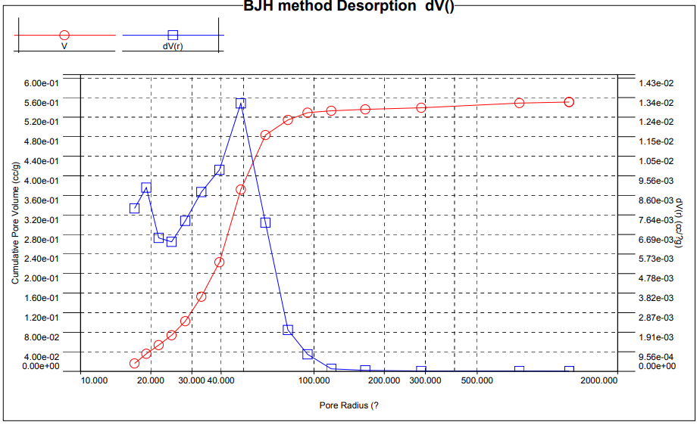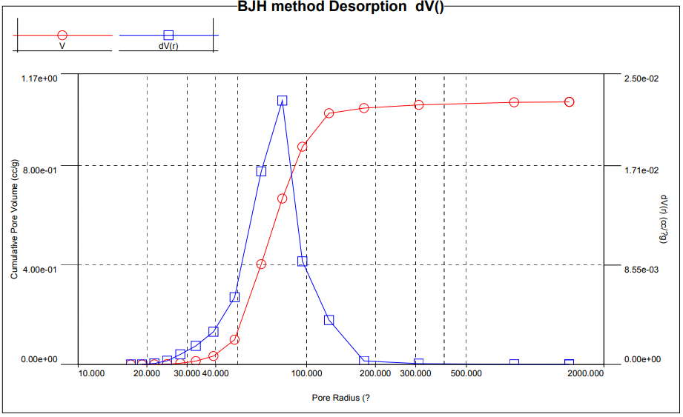
b
a
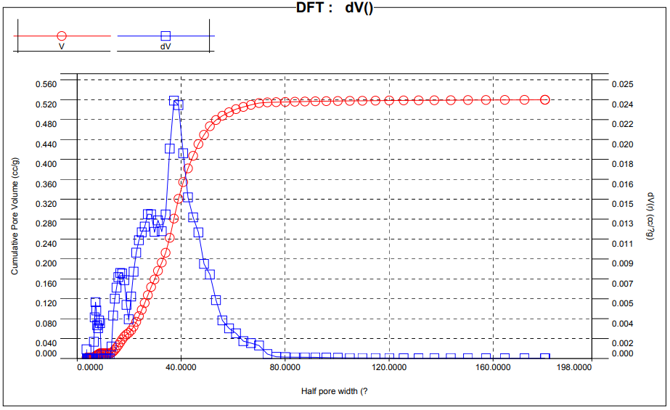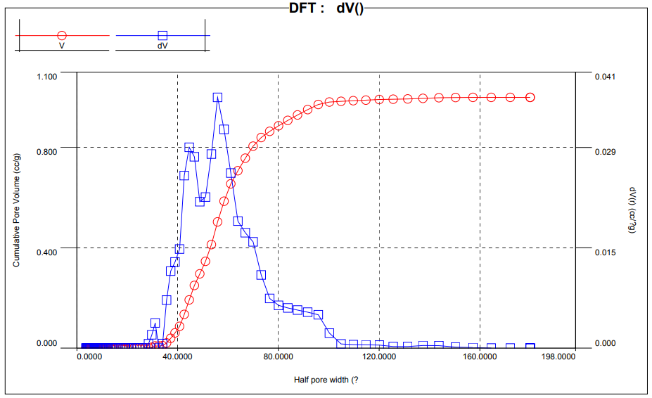
d
c
Figure 6. BJH (a, b) and DFT (c, d) pore size distribution curves for PAN–SiO₂ hybrid nanocomposites with ratios 1:2 and 2:1.

A more detailed description of the pore structure is obtained using Density Functional Theory (DFT), which provides a more accurate analysis of micro- and mesopores. The DFT results confirm the observed trends, showing an increase in pore volume from 0.520 to 1.000 cm³/g and an increase in average pore size from 46.42 Å to 91.92 Å when moving from PAN–SiO₂ = 1:2 to 2:1. At the same time, the specific surface area remains relatively stable (171.03–178.10 m²/g), indicating that structural changes are primarily associated with pore enlargement rather than the formation of new surface area.
A key finding of the analysis is the dominant contribution of micropores to the overall pore structure. The fraction of micropores reaches extremely high values of 99.53% for the PAN–SiO₂ = 1:2 sample and 94.61% for the 2:1 composition, while the corresponding contribution to surface area is approximately 63.6–64.0%. These results indicate that the adsorption capacity of the materials is primarily governed by microporosity, whereas meso- and macropores play a supporting role by facilitating mass transport.
The observed dependence of pore characteristics on composition provides important insight into the mechanism of structure formation. An increase in PAN content leads to an increase in pore volume and average pore size, suggesting that the polymer phase prevents excessive densification of the silica network and promotes the formation of a more open structure. This effect can be attributed to steric interactions between polymer chains and growing silica clusters, which limit aggregation and favor the formation of interconnected pore channels.
Overall, the combined analysis using BET, V–t, BJH, and DFT methods demonstrates that PAN–SiO₂ hybrid nanocomposites possess a hierarchical pore structure characterized by dominant microporosity and a significant contribution of mesopores. Such a multiscale architecture provides an optimal balance between adsorption capacity and transport properties and is a direct consequence of the sol–gel synthesis in the presence of polymer chains. The results clearly show that the pore structure of the hybrid materials can be effectively tuned by varying the composition, making them promising candidates for advanced adsorption and separation applications.
3.5. Water Vapor Adsorption within the de Boer–Zwikker Framework
The adsorption behavior of water vapor in PAN–SiO₂ hybrid nanocomposites was analyzed within the framework of the de Boer–Zwikker theory, which is specifically applicable to systems involving polar adsorbates and polar porous materials. This approach allows separation of “true adsorption,” associated with direct interaction between adsorbate molecules and active surface sites, from secondary processes such as capillary condensation and cluster formation.
Linearization of the adsorption isotherms in the coordinates of the de Boer–Zwikker equation reveals a fundamental difference between pristine components and hybrid systems. For PAN–SiO₂ composites, the adsorption plots remain nearly linear over the entire range of relative pressures, whereas for pristine PAN and SiO₂, linearity is observed only within a narrow region at high relative pressures (P/P₀ ≈ 0.8–0.9). This indicates that, in hybrid systems, adsorption proceeds predominantly via direct interaction with surface functional groups and is not significantly influenced by capillary condensation effects (figure 7).

a | b
Figure 7. Water vapor adsorption isotherms represented in de Boer–Zwikker coordinates: (a) pristine PAN (1) and SiO₂ (2); (b) PAN–SiO₂ hybrid (1) and PAN–SiO₂–glycerol (2). The enhanced linearity observed for hybrid systems indicates true adsorption dominated by surface interactions.

The extended linearity of the de Boer–Zwikker plots suggests that, within the investigated pressure range, water molecules are predominantly bound to active adsorption centers and do not form a free or bulk-like condensed phase in the pore space. In contrast, the limited linearity observed for pristine materials indicates the onset of capillary condensation and clustering at higher relative pressures.
The adsorption parameters calculated from water vapor isotherms further support this conclusion. The monolayer capacity (Xₘ) increases from 0.0059 g/g for pristine PAN to 0.0097 g/g for PAN–SiO₂ (1:3), while the specific surface area (S_{BET}) increases from 2.72 to 34.07 m²/g, indicating significant development of accessible adsorption sites. At the same time, the Gibbs free energy values increase from −2.19 J/mol (PAN) to −6.32 J/mol, with integral values reaching −7.40 J/mol, reflecting stronger adsorbate–adsorbent interactions.
These thermodynamic parameters should not be interpreted as direct outputs of the de Boer–Zwikker model but rather as complementary evidence supporting the dominance of surface-controlled adsorption. The increase in adsorption energy confirms the enhanced interaction between water molecules and the hybrid surface, which is consistent with the observed linear behavior of the isotherms.
From a structural perspective, this behavior is attributed to the presence of a high density of hydrophilic functional groups, including silanol (Si–OH) groups and nitrile (–C≡N) groups of PAN, which act as active adsorption centers capable of forming hydrogen bonds. The formation of hybrid networks during sol–gel synthesis leads to a more homogeneous distribution of these sites, resulting in a uniform adsorption mechanism over a wide pressure range.
Thus, the combined analysis of adsorption isotherms and their linearization in de Boer–Zwikker coordinates demonstrates that water adsorption in PAN–SiO₂ hybrid nanocomposites is governed by surface interactions rather than by capillary condensation. This confirms that, within the studied pressure range, water is present in a bound state associated with active surface sites, and the adsorption process should be considered as a surface-controlled phenomenon determined by the distribution and accessibility of adsorption centers.
3.6. Adsorption–Calorimetric Analysis of PAN–SiO₂ Hybrid Nanocomposites
Polymer–inorganic hybrid nanocomposites based on PAN–SiO₂ represent a class of structurally complex systems in which adsorption behavior is governed by a combination of geometric confinement, surface chemistry, and energetic heterogeneity. Water adsorption: multi-stage energetics and cooperative structuring

Figure 8. Water adsorption isotherm of PAN–SiO₂ hybrid nanocomposite at 303 K plotted as ln(p/p₀) vs adsorption capacity; experimental data are well reproduced by TVFM modeling, indicating a micropore-filling adsorption mechanism.

The adsorption isotherm of water vapor exhibits a strongly non-linear profile in semi-logarithmic coordinates, with a pronounced concave region at low relative pressures (P/P₀ ≈ 0.06–0.075), indicating the presence of high-energy adsorption sites. These sites correspond to silanol (Si–OH) groups of silica and nitrile (–C≡N) groups of PAN, which act as hydrogen-bond donors and acceptors, respectively. The strong interaction between water molecules and these functional groups leads to preferential adsorption at low coverage (figure 8).
At higher relative pressures, the isotherm transitions into a quasi-linear region and ultimately reaches saturation at 3.79 mmol/g (P/P₀ ≈ 0.95), indicating the filling of the pore space. Compared to alternative hybrid systems (e.g., 2.92 mmol/g), this value confirms the enhanced adsorption capacity of PAN–SiO₂ nanocomposites and reflects both increased surface functionality and improved pore accessibility.
The adsorption mechanism is quantitatively described within the framework of the Theory of Volume Filling of Micropores (TVFM) using a three-term equation:
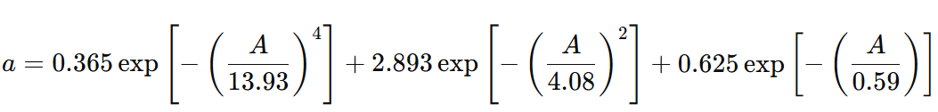
The corresponding characteristic energies (13.93, 4.08, and 0.59 kJ/mol) indicate the presence of three distinct adsorption domains. The first term, contributing approximately 85% of the total adsorption, corresponds to strong adsorption in micropores. The second and third terms represent intermediate and weak adsorption in larger pores and less active regions.
This distribution of adsorption energies reflects a heterogeneous energy landscape, where adsorption proceeds through multiple parallel mechanisms depending on pore size and surface functionality.
Thermodynamic transitions and clustering effects
The calorimetric data provide a detailed picture of the energetics of adsorption. The differential heat of adsorption exhibits a stepwise profile, decreasing from 110 kJ/mol at low coverage to 43.54 kJ/mol at high coverage, which corresponds to the heat of condensation of water (figure 9). This behavior indicates a transition from strong surface adsorption to bulk-like condensation within the pore system.
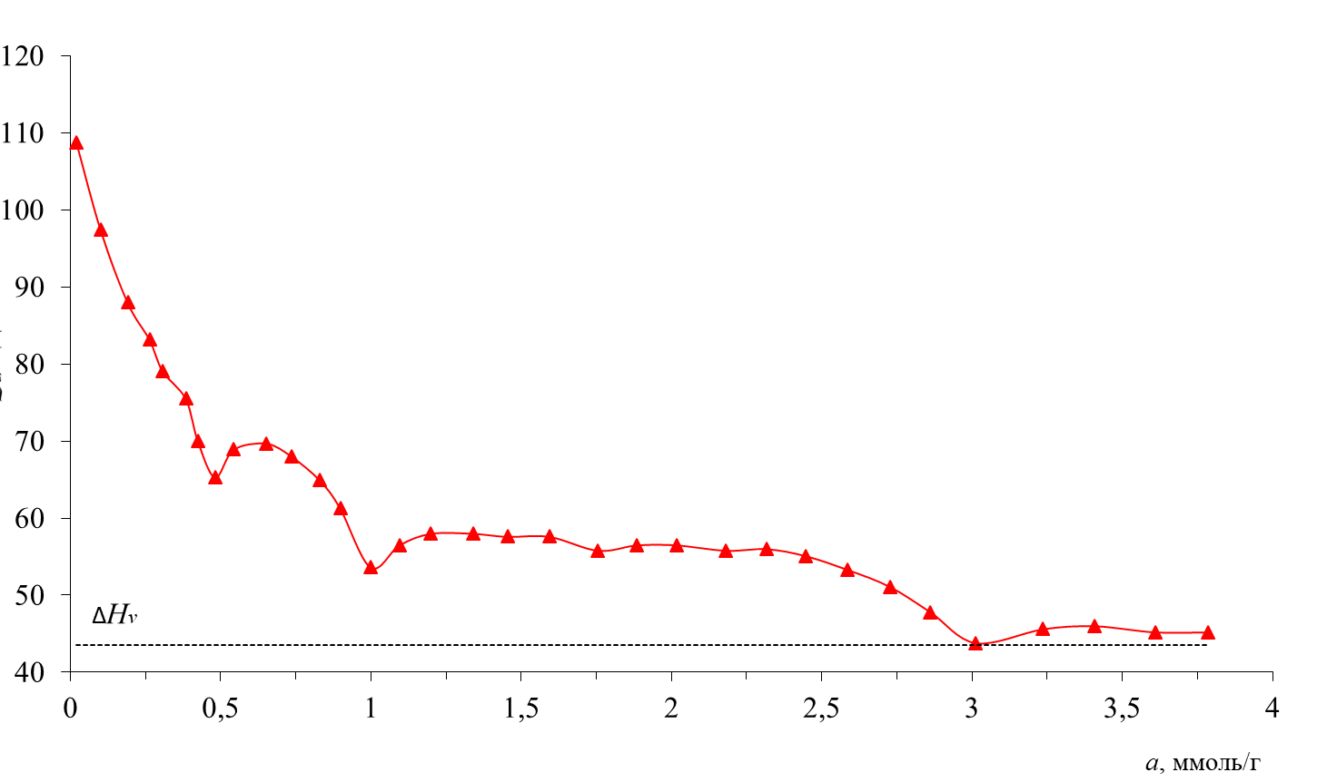
Q_{d}, kJ/mol
a, mmol/g
Figure 9. Differential heats of water adsorption on PAN–SiO₂ hybrid nanocomposites at 303 K; the dashed horizontal line denotes the heat of condensation, highlighting the evolution of adsorption energetics with increasing surface coverage.

The adsorption process can be divided into five distinct stages:
Primary adsorption (0–0.48 mmol/g):
Strong adsorption on high-energy sites, with heat decreasing from 110 to 65.3 kJ/mol.
This stage corresponds to direct interaction with surface functional groups.
Secondary adsorption (0.48–1.0 mmol/g):
Moderate decrease in heat (65.3–53.6 kJ/mol), indicating adsorption on less energetic sites.
Cooperative adsorption (1.0–1.76 mmol/g):
Slight increase in heat (53.8–55.8 kJ/mol), suggesting the onset of intermolecular interactions.
Cluster stabilization (1.76–2.32 mmol/g):
Nearly constant heat (~56 kJ/mol), corresponding to stable cluster formation.
Pore filling (2.32–3.0 mmol/g):
Decrease in heat toward 43.54 kJ/mol, indicating transition to a quasi-liquid phase.

The formation of hydrogen-bonded clusters (H₂O)ₙ within the pore space is a key feature of this system and reflects cooperative adsorption under confinement.
Entropy and confinement effects
The entropy analysis reveals strong confinement effects. The differential entropy decreases to −147 J/mol·K at low coverage, indicating a highly ordered state of adsorbed molecules. As adsorption progresses, the entropy gradually increases and approaches the value of liquid water at saturation (figure 10).
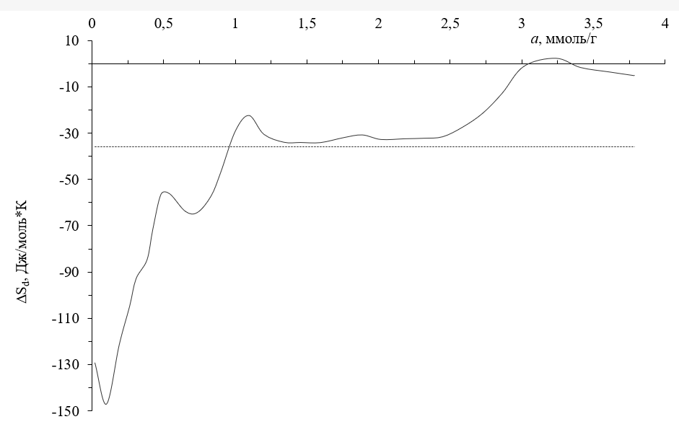
∆S_{d}, J/mol*K
a, mmol/g
Figure 10. Differential entropy of water adsorption on PAN–SiO₂ hybrid nanocomposites at 303 K; the horizontal dashed line denotes the integral molar entropy, referenced to zero entropy of liquid water, illustrating the restricted mobility and ordering of adsorbed species.

The integral entropy (−36 J/mol·K) remains significantly lower than that of bulk water, confirming that the adsorbed phase remains highly structured even at high coverage. This behavior is characteristic of confined adsorption in microporous systems and reflects restricted molecular mobility.

Kinetic regimes and adsorption dynamics
The adsorption kinetics further supports the multi-stage mechanism. At low coverage, the time required to reach equilibrium reaches ~8.8 hours, indicating slow adsorption due to strong interactions with high-energy sites. At intermediate coverage, equilibrium is achieved within ~2 hours, while at high coverage, the process accelerates significantly, with equilibrium reached within ~70 minutes (figure 11).
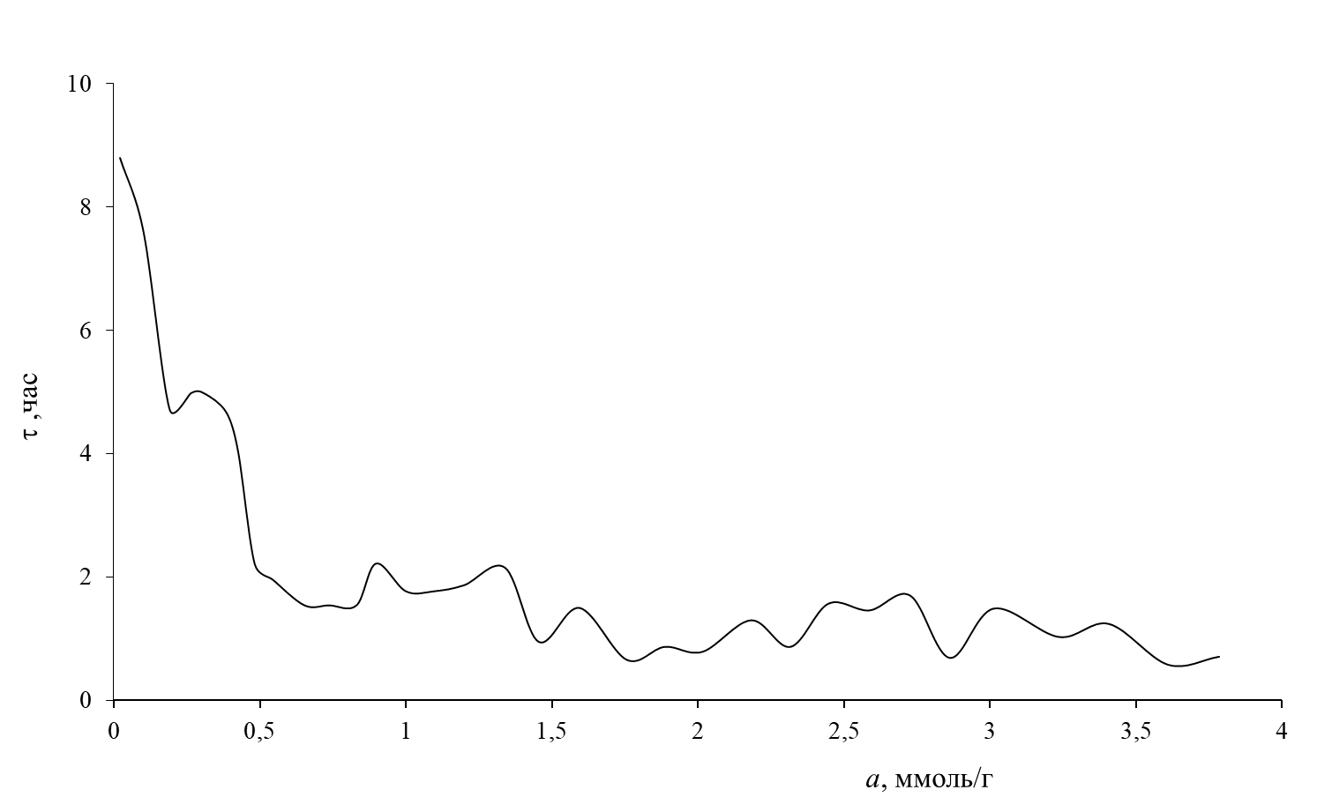
τ, hour
a, mmol/g
Figure 11. Dependence of equilibrium adsorption time on water uptake in PAN–SiO₂ hybrid nanocomposites, reflecting the influence of adsorption energetics and pore structure on kinetic behavior.

This non-linear kinetic behavior reflects a transition from interaction-controlled adsorption to diffusion-controlled processes and is consistent with the formation of hierarchical pore structures.
Benzene Adsorption: Mechanism, Thermodynamics, and Kinetics
The adsorption behavior of benzene on PAN–SiO₂ hybrid nanocomposites exhibits distinct features that reflect the combined influence of pore structure and weak dispersive interactions. The adsorption isotherm, presented in semi-logarithmic coordinates, shows a concave profile at low relative pressures (P/P₀ ≈ 0.042–0.106), indicating the presence of energetically active adsorption centers and the initial stage of micropore filling (figure 12).

Figure 12. Benzene adsorption isotherm on PAN–SiO₂ hybrid nanocomposite at 303 K; the calculated values based on TVFM (black symbols) closely reproduce the experimental data, indicating a dominant micropore-filling mechanism.
As the relative pressure increases, the isotherm transitions into a quasi-linear region and approaches saturation at 0.99 mmol·g⁻¹ at P/P₀ ≈ 0.95, which is significantly lower than the corresponding value for water adsorption (3.79 mmol·g⁻¹). This difference highlights the fundamentally different adsorption mechanisms: benzene adsorption is governed by weak dispersive interactions, whereas water adsorption is dominated by strong specific interactions.
The adsorption process is well described within the framework of the Theory of Volume Filling of Micropores (TVFM) using a three-term equation:
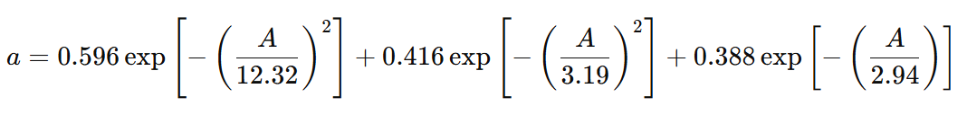
The obtained parameters indicate three distinct adsorption domains characterized by energies of 12.32, 3.19, and 2.94 kJ·mol⁻¹, respectively. The dominant contribution corresponds to the first term, which represents adsorption in micropores, accounting for approximately 85% of the total adsorption capacity. The remaining terms describe adsorption in larger pores and less energetic regions.
The excellent agreement between calculated and experimental isotherms confirms the applicability of the TVFM model and demonstrates that benzene adsorption is primarily controlled by pore geometry rather than chemical interactions.
Thermodynamic behavior
The differential heat of adsorption decreases from 98.5 to 38.7 kJ·mol⁻¹, approaching the heat of condensation, indicating a transition from micropore filling to multilayer adsorption (figure 13).
Calorimetric analysis reveals a characteristic stepwise variation of the differential heat of adsorption. At low coverage, the heat decreases sharply from 98.5 to 55.6 kJ·mol⁻¹, indicating adsorption on high-energy sites. As adsorption progresses, the heat decreases more gradually from 55.6 to 46.7 kJ·mol⁻¹ within the range 0.06–0.406 mmol·g⁻¹, corresponding to adsorption on moderately energetic sites.
At intermediate coverages (0.406–0.609 mmol·g⁻¹), the heat continues to decrease to 41.6 kJ·mol⁻¹, and in the final stage (0.609–0.983 mmol·g⁻¹), it approaches 38.7 kJ·mol⁻¹, which is close to the heat of condensation of benzene (43.54 kJ·mol⁻¹). This behavior indicates a gradual transition from localized adsorption to multilayer formation and capillary condensation.
Unlike water, benzene adsorption does not exhibit cooperative effects, and no increase in adsorption heat is observed at intermediate coverage. This confirms the absence of strong intermolecular interactions between adsorbed molecules.

Figure 13. Differential heats of benzene adsorption on PAN–SiO₂ hybrid nanocomposites at 303 K; the decrease in Qₐ with increasing adsorption reflects progressive occupation of sites with lower energy, while the dashed line denotes the heat of condensation of benzene.

Entropy and molecular mobility
The entropy of adsorption shows a significant decrease at low coverage, reaching values down to −110.25 J·mol⁻¹·K⁻¹ within the range 0.005–0.02 mmol·g⁻¹, indicating a high degree of confinement and ordering of benzene molecules in micropores. With increasing adsorption, the entropy gradually increases and crosses the entropy of liquid benzene near saturation (0.983 mmol·g⁻¹).

Figure 14. Differential entropy of benzene adsorption on PAN–SiO₂ hybrid nanocomposites at 303 K; the negative entropy values indicate restricted molecular mobility under confinement, while the dashed line denotes the integral molar entropy referenced to liquid benzene.
The integral entropy value (−58.16 J·mol⁻¹·K⁻¹) remains significantly lower than that of the bulk liquid, confirming that the adsorbed benzene remains in a constrained state within the pore structure. This indicates that, although interactions are weak, geometrical confinement still plays a significant role.
Kinetic behavior
The adsorption kinetics of benzene is considerably faster than that of water. At low coverage, equilibrium is reached within 2–3.5 hours, while at higher coverage, the process accelerates and equilibrium is established within approximately 40 minutes

Figure 15. Dependence of equilibrium adsorption time on benzene uptake in PAN–SiO₂ hybrid nanocomposites, reflecting the influence of adsorption energetics and pore structure on kinetic behavior.

The dependence of equilibrium time on adsorption capacity reflects the presence of multiple kinetic regimes. Initially, adsorption is controlled by interactions with high-energy sites, while at higher coverage, diffusion and pore filling dominate. The absence of long equilibration times, as observed for water (up to 8.8 hours), further confirms the weaker interaction of benzene with the hybrid surface.
Mechanistic interpretation
The overall adsorption mechanism of benzene in PAN–SiO₂ hybrid nanocomposites can be described as a combination of:
micropore filling (dominant contribution, ~85%),
multilayer adsorption,
capillary condensation at high pressures,
without significant contribution from cooperative or cluster-driven processes.
Thus, benzene adsorption is primarily controlled by the geometrical characteristics of the pore system, including pore size, connectivity, and accessibility, rather than by surface chemistry.

CONCLUSIONS
A comprehensive investigation of PAN–SiO₂ hybrid nanocomposites revealed a strong relationship between synthesis conditions, structural organization, pore architecture, and adsorption thermodynamics. The sol–gel process in the presence of PAN leads to the formation of interpenetrating polymer–inorganic networks, which govern pore accessibility and connectivity.
The adsorption properties are highly sensitive to composition, with an optimal ratio of PAN–SiO₂ ≈ 1:3 providing maximum performance. At this composition, the monolayer capacity reaches 0.0085 g/g (benzene) and 0.0097 g/g (water), while the specific surface area increases up to 20.01 m²/g and 34.07 m²/g, respectively.
A clear distinction between adsorption mechanisms was established. Benzene adsorption is controlled by pore geometry and weak dispersive interactions, whereas water adsorption is governed by strong specific interactions, resulting in a significantly higher uptake (3.79 vs 0.99 mmol/g). Nitrogen adsorption confirms the formation of a hierarchical pore structure with a surface area up to 236 m²/g and micropore contribution of ~95%.
Thermodynamic analysis demonstrates pronounced surface heterogeneity, with differential heats of adsorption up to 110 kJ/mol (water) and 98.5 kJ/mol (benzene), and strongly negative entropy values (down to −147 J/mol·K), indicating confined adsorption.
Overall, PAN–SiO₂ hybrid nanocomposites represent tunable adsorption systems in which pore structure and surface energetics can be controlled through synthesis. These materials show strong potential for applications in gas purification, water treatment, and advanced separation technologies.

REFERENCES

- McLean B., Smith J., Brown K. Structure, properties, and applications of silica-based hybrid materials // Small. – 2024. – Vol. 20. – Article 2405299. DOI: 10.1002/smll.202405299.
- Banaei A., Saadat A., Gharibzadeh N. Synthesis and characterization of silica-based hybrid nanocomposites for adsorption applications // RSC Advances. – 2024. – Vol. 14. – P. 1007–1021. DOI: 10.1039/D4RA01007H.
- Youssif M.M., Hassan H.S., Ali R.M. Amino-functionalized Fe₂O₃/SiO₂ nanocomposites for efficient adsorption of heavy metals // Materials. – 2024. – Vol. 17. – 4254. DOI: 10.3390/ma17174254.
- Al Alwan B., Kareem M., Hassan A. PAN-based hybrid nanocomposites: synthesis, characterization and adsorption properties // Materials Chemistry and Physics. – 2025. – Vol. 315. – 125456. DOI: 10.1016/j.matchemphys.2025.125456.
- Tewari S., Gupta R., Singh P. Recent advances in nanostructured adsorbents: synthesis and adsorption behavior // Nanomaterials. – 2026. – Vol. 16. – 233. DOI: 10.3390/nano14020233
- Islam M.A., Khan M.N., Rahman M. Polymer–silica nanocomposites: synthesis, structure and adsorption performance // Silicon. – 2025. – Vol. 17. – P. 3262–3275. DOI: 10.1007/s12633-022-02062-2.
- Girish C.R. Determination of thermodynamic parameters in adsorption studies: a review // Chemical Papers. – 2025. – Vol. 79. – P. 1123–1142. DOI: 10.1007/s11696-020-01436-4
- Coudert F.-X. Thermodynamics of adsorption in nanoporous materials: structure–property relationships // Advanced Theory and Simulations. – 2019. – Vol. 2. – 1900131. DOI: 10.1002/adts.201900131.
- Thommes M., Kaneko K., Neimark A.V., et al. Physisorption of gases, with special reference to the evaluation of surface area and pore size distribution (IUPAC Technical Report) // Pure and Applied Chemistry. – 2015. – Vol. 87. – P. 1051–1069. DOI: 10.1515/pac-2014-1117.
- Li Y., Wang X. Adsorption mechanisms in polymer-based hybrid materials: influence of surface chemistry and pore structure // Journal of Hazardous Materials. – 2022. – Vol. 424. – 127530. DOI: 10.1016/j.jhazmat.2021.127530.
- Sanchez C., Julián B., Belleville P., Popall M. Applications of hybrid organic–inorganic nanocomposites // Journal of Materials Chemistry. – 2005. – Vol. 15. – P. 3559–3592. DOI: 10.1039/B509097K.
- Kickelbick G. Hybrid Materials: Synthesis, Characterization, and Applications. – Wiley-VCH, 2007. – 498 p.
- Rouquerol F., Rouquerol J., Sing K.S.W., Llewellyn P., Maurin G. Adsorption by Powders and Porous Solids: Principles, Methodology and Applications. – 2nd ed. – Academic Press, 2014. – 646 p.
- Thommes M., Kaneko K., Neimark A.V., Olivier J.P., Rodriguez-Reinoso F., Rouquerol J., Sing K.S.W. Physisorption of gases with special reference to the evaluation of surface area and pore size distribution // Pure and Applied Chemistry. – 2015. – Vol. 87. – P. 1051–1069. DOI: 10.1515/pac-2014-1117.
- Everett D.H. Thermodynamics of adsorption // Pure and Applied Chemistry. – 1972. – Vol. 31. – P. 577–638. DOI: 10.1351/pac197231040577
- Dubinin M.M. Fundamentals of the theory of adsorption in micropores // Carbon. – 1989. – Vol. 27. – P. 457–467. DOI: 10.1016/0008-6223(89)90078-9.
- Каттаев Н.Т., Маматов Ж.К., Яркулов А.Ю., Рузимурадов О.Н., Акбаров Х.И. // Синтез и исследование ПАН-кремнеземных гибридных композиционных материалов // Композиционные материалы, 2020. – №4. – С.237-239.
- Маматов Ж. К., Рузимурадов О.Н., Каттаев Н.Т., Акбаров Х.И. // Изучение капиллярно-пористой структуры гибридных ПАН-кремнеземных композиций // Узбекский химический журнал, 2020. – №3. – C.16-22.
- Каттаев Н., Акбаров Х., Маматов Ж. Синтез и физико-химические свойства новых ПАН-кремнеземных композитов. LAP lambert Academic Publishing, 2022. – 149 c.

