REACTIVE MOLECULAR DYNAMICS STUDY OF CARBAMAZEPINE DEGRADATION UNDER COLD ATMOSPHERIC PLASMA

Murodali Mamanazarov¹, Azizova Madina², Jamoliddin Razzokov³,
¹Faculty of Chemistry, National University of Uzbekistan, Tashkent, 100034, Uzbekistan, ²Faculty of Industrial Pharmacy, Institute of Pharmaceutical Education and Research, 100114 Tashkent, Uzbekistan, ³Institute of Fundamental and Applied Research, National Research University TIIAME, 100000 Tashkent, Uzbekistan
https://orcid.org/0009-0009-3208-7861

ABSTRACT
This study provides an investigation of the reactivity of the carbamazepine toward plasma-generated reactive oxygen species, particularly atomic oxygen, using reactive molecular dynamics simulations. Based on 100 initial trajectories computed via the DFTB+ method, the most frequently formed product was selected and subjected to atomic oxygen additions, modeling its transformation up to total degradation. The simulations revealed key oxidative processes, including hydroxylation, epoxide formation, ring opening and closing, fragmentation, and the release of small molecules such as CO₂ and NH₂. These results elucidate at the molecular level, the complex degradation pathways of carbamazepine and highlight the oxidation of carbonyl and amino groups as routes of mineralization. The identified reaction pathways show qualitative agreement with experimentally observed products following plasma treatment. The proposed computational approach offers a theoretical framework for developing efficient and controllable plasma-based degradation strategies for pharmaceutical contaminants.

KEY WORDS: Carbamazepine; cold atmospheric plasma; atomic oxygen; reactive molecular dynamics; DFTB+; oxidative degradation.

INTRODUCTION
The widespread detection of pharmaceuticals and personal care products in the environment has become a important global ecological concern in recent years. Although these products play an important role in safeguarding human health, they tend to persist and accumulate once released into aquatic systems. Especially, stable compounds such as diclofenac, sulfamethoxazole, and carbamazepine (CBZ) often remain undegraded in conventional biological or chemical treatment processes, ultimately entering natural water bodies where they pose ecological risks [1-2]. For this reason, they are increasingly classified as emerging environmental contaminants. CBZ, a widely prescribed antiepileptic drug, is especially problematic due to its resistance to metabolic breakdown and its persistence in water. As a result, CBZ is detected worldwide in rivers, lakes, wastewater, and even drinking water supplies [3]. Experimental studies further indicate that certain transformation products generated during CBZ degradation may exhibit toxicity levels comparable to, or even greater than, that of the parent compound [4]. This underscores the need for efficient and environmentally benign degradation strategies.
Among advanced oxidation processes, cold atmospheric plasma (CAP) has emerged as a sustainable and highly effective method for wastewater purification. CAP is a non-thermal plasma comprising ions, electrons, neutral species, and reactive oxygen and nitrogen species (RONS) [5]. These species, such as •O, •OH, O₃, NO, and NO₂, show strong oxidative capabilities capable of breaking down complex organic molecules. Key advantages of CAP treatment include its low operating temperature, chemical-free operation, energy efficiency, and renewability [1]. However, elucidating the molecular-level mechanisms of CBZ degradation under CAP only through experimental techniques remains challenging. RMD simulations allow real-time tracking of bond cleavage and formation events. Density Functional Tight Binding (DFTB+) method, which offers a balance between computational efficiency and quantum-level accuracy, has been successfully applied to study the oxidation of various organic pollutants, including dyes and pharmaceuticals [6].
In this study, the reactions between CBZ and atomic oxygen were investigated using an RMD framework implemented in DFTB+. First, 100 independent trajectories of a single O atom interacting with CBZ were simulated, with randomized initial positions to ensure configurational sampling. After identifying the most frequently occurring reaction pathway, additional simulations incorporating multiple O atoms were conducted to resolve downstream transformations. The aim of the work was to describe, at the molecular scale, the stepwise decomposition of CBZ, the formation of intermediate species, and the progression toward complete mineralization into CO₂ and H₂O.

SIMULATION PARAMETERS
RMD simulations were carried out to elucidate the degradation mechanism of CBZ under the influence of cold atmospheric plasma. All computations were performed using DFTB+ method, a parametrized approach derived from a Taylor expansion of the Density Functional Theory (DFT) total energy expression. Compared with classical quantum-chemical calculations and conventional reactive MD schemes, DFTB offers a substantial reduction in cost. In particular, relative to highly parameterized force-field-based methods such as ReaxFF-MD, DFTB is considerably more efficient and can operate up to two orders of magnitude faster than full DFT calculations [7].
Despite its computational efficiency, DFTB retains the ability to accurately describe hydrogen-bond energetics, proton-affinity trends, and the activation barriers associated with hydrogen-transfer reactions [8]. Moreover, the method reliably represents conjugated and resonance-stabilized molecular frameworks, features that are often inadequately captured by ReaxFF-MD. That’s why, DFTB is widely regarded as a robust and practical tool for modeling complex intra- and intermolecular reaction pathways [9].
To describe interatomic interactions in the present simulations, the “3ob-3-1” parameter set-optimized specifically for organic and biological molecules was employed [10]. These parameters were developed to ensure accurate representation of the electronic characteristics of oxygen, carbon, nitrogen, and hydrogen atoms.
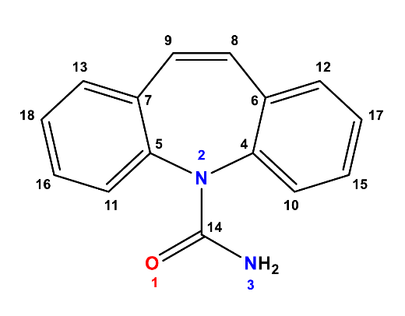
Figure 1. Molecular structure of CBZ.

The CBZ molecule consists of 31 atoms (Figure 1) and was modeled as the primary substrate interacting with atomic oxygen. Each RMD trajectory was propagated for 200 000 integration steps with a timestep of 0.4 femtoseconds (fs), corresponding to a total simulation time of 80 picoseconds (ps) per trajectory. The equations of motion were integrated using the Velocity-Verlet algorithm. The system temperature was maintained at 300 K using a Berendsen thermostat with a damping constant of 100 fs.
All simulations were carried out in a periodic simulation box that mimics gas-phase conditions, allowing the molecules to move freely without solvent effects. Calculations were performed within the DFTB+ framework, incorporating self-consistent charge redistribution, dispersion corrections, Lennard-Jones interactions, and full third-order energy terms. This parameter set enabled reliable molecular-scale modeling of the complex reaction pathways and degradation mechanisms occurring between CBZ and atomic oxygen.

RESULTS AND DISCUSSION
The influence of reactive oxygen species generated in plasma, especially atomic oxygen, on the degradation of CBZ was examined through oxygen molecule interactions. To identify the key bond-cleavage events and the formation of new chemical bonds, 100 independent DFTB-based molecular dynamics simulations were performed. The CBZ molecule, consisting of 31 atoms, was positioned at the center of a cubic simulation box measuring 30 × 30 × 30 Å. Its initial geometry was optimized using the Conjugate Gradient algorithm. Then, system was gradually heated and equilibrated over a total of 103 picoseconds, during which the temperature was raised to 300 K under the control of a Berendsen thermostat. All trajectories were propagated with a timestep of 0.4 femtoseconds (fs). In each simulation, to prevent premature long-range interactions, an oxygen atom was placed at a random position at least 5 Å away from the CBZ molecule. Among the resulting structures, the most frequently formed intermediate containing a newly created C-O bond was selected for further analysis. Additional atomic oxygen was then introduced to probe the subsequent stages of oxidative decomposition. The simulations successfully captured the reactive behavior of CBZ toward oxygen radicals and showed agreement with experimental observations.
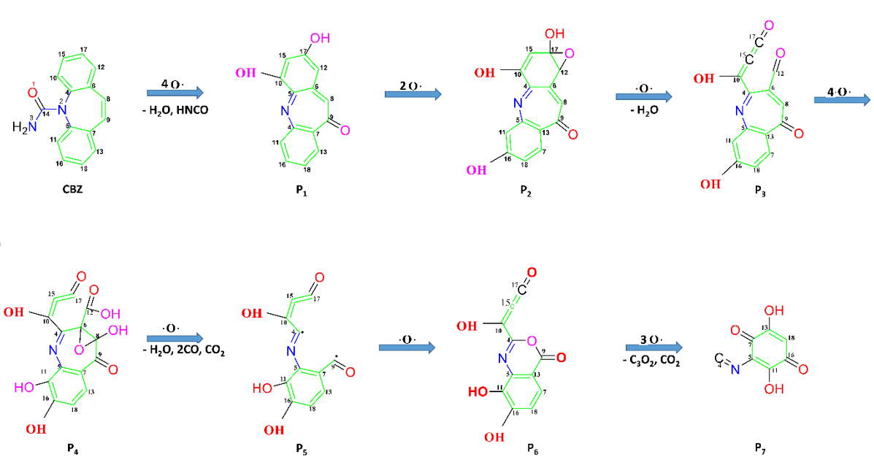
Figure 2. Schematic representation of the initial reaction stages observed in the simulations.

For the second-stage simulations, the most frequently observed intermediate from the 100 trajectories of the first stage was selected as the starting configuration. The interaction of carbamazepine with atomic oxygen was first examined by introducing a single O atom into the simulation box and performing 100 independent DFTB-MD trajectories. In these simulations, the initial reactions were dominated by hydrogen abstraction events, followed by rapid formation of C-O bonds at electron-rich sites of the CBZ molecule. Among the resulting structures, the most frequently observed intermediate contained a newly formed C-O bond at the C₉ position, indicating that this site represents a preferred reaction center under oxygen-rich plasma conditions. For subsequent simulations, this dominant intermediate was selected as the starting configuration. When additional atomic oxygen was introduced, hydroxylation at the C₉ site was consistently observed, resulting from hydrogen abstraction and subsequent OH attachment. In our simulations, this modification effectively defined a new chemically active center within the CBZ framework, from which further oxidation reactions evolved. At this stage, the reaction behavior was strongly influenced by the local electronic structure and steric environment surrounding the C₉ position. Additional O atoms introduced during the simulation generated multiple new OH groups at different locations of the molecule. A further reactive event occurred when another O atom abstracted two hydrogen atoms (one from an OH group and one from the NH₂ group), creating a highly unstable species. This triggered the cleavage of the C₁₄-N₂ bond and the formation of product P₁. To better elucidate this process, time-dependent variations in interatomic distances and the total energy were analyzed (Figure 3). Initially, the O₃₄-H₂₀ and O₃₄-H₃₀ distances were relatively large, but they rapidly decreased and stabilized at short values, indicating the formation of strong O-H bonds and the transfer of the corresponding hydrogen atoms to O₃₄. This hydrogen abstraction and subsequent bond formation disrupted electronic structure and local geometry of the molecule, leading to break of the C₁₄-N₂ bond. A marked increase in their distance confirmed the cleavage of this covalent bond. These structural changes consistent with the energy profile. As shown in Figure 3B, the period corresponding to O₃₄-H₂₀/H₃₀ bond formation and C₁₄-N₂ bond rupture displayed a drop in potential energy, consistent with the formation of stable O-H bonds. While the total energy exhibited a generally decreasing trend, the kinetic energy showed fluctuations. In particular, fluctuations observed between steps 18 000 and 22 000 indicated increased molecular mobility and transient instability. The combined analysis of energy and atomic distances demonstrates that the molecule undergoes complex bond rearrangements and fragmentation during the simulation, and these transformations significantly influence its structural evolution and overall reactivity.
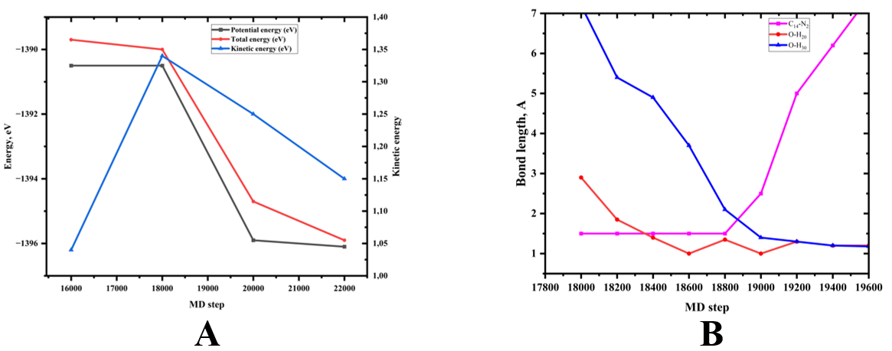
Figure 3. Time evolution of the system energy (A) and (B) key interatomic distances during the simulation.

One of the key changes observed in the next simulation stages was the opening of the aromatic and heterocyclic rings within the CBZ molecule, as well as the formation of new ring-like structures. These processes were driven by the redistribution of reactive centers, shifts in electron density, and structural rearrangements that promote fragmentation. O atoms introduced into the system further modified the P₁ intermediate by generating new OH groups and enabling oxygen insertion into the ring system. Continued oxygen exposure promotes electrophilic attack on unsaturated C-C bonds, most notably the C₁₇-C₁₂ double bond, leading to epoxidation and formation of three-membered C-O-C ring (P₂). This epoxide serves as a highly reactive intermediate that disrupts local conjugation and enhances molecular instability. Subsequent oxygen-induced opening of the epoxide ring triggers simultaneous rupture of the adjacent aromatic framework, resulting in extensive ring opening and formation of intermediates (P₃). As oxidation progresses, repeated hydroxylation events and oxygen insertions further weaken the molecular backbone. Oxygen attack on the seven-membered heterocycle leads to additional C-O-C formation, followed by complete ring rupture. These fragmentation steps are accompanied by the release of low-molecular-weight species such as H₂O, CO, and CO₂, indicating partial mineralization of the initial compound. Upon introduction of an additional atomic oxygen to the P₅ intermediate, another intriguing transformation was observed. The previously opened ring fragment underwent intramolecular re-closure through the C₄ and C₉ positions, resulting in the formation of a new six-membered ring (P₆). Analysis of the interatomic distance profiles shown in Figure 4 reveals that the incoming oxygen atom initially approached the C₉ atom and formed a stable covalent bond. At this stage, the C₄ atom was already engaged in a double bond interaction with the O₁₂ atom, but, new oxygen atom attacked and destabilized this arrangement. As a consequence, distance between C₉-O₁₂ increased, indicating conversion of the original double bond into a single covalent bond. Simultaneously, the position of the O₁₂ atom began to shift toward the C₄ atom, as evidenced by the emergence of a short and stable interatomic distance in the corresponding distance plot. This behavior confirms the formation of a new O₁₂-C₄ bond. The sequential rearrangement of these bonds ul led to the closure of a newly formed six-membered heterocycle incorporating an oxygen atom within the molecular framework. The associated energy profile supports the energetic feasibility of this structural transformation. A stepwise decrease in potential energy consistent with the formation of new covalent bonds, indicating stabilization of the system. The total energy continues to decline throughout this process, reflecting the transition of the molecule toward a more stable configuration. In contrast, the kinetic energy exhibits little increases during the reactive intervals, consistent with enhanced atomic mobility and intensified interatomic dynamics during bond rearrangement.
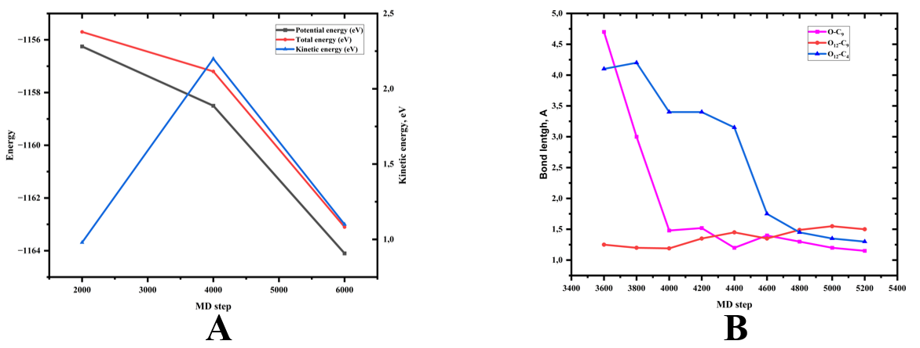
Figure 4. Time evolution of system energy (A) and interatomic distances (B) during the formation of the oxygen-containing six-membered ring.

Sequential exposure of the P₆ intermediate to additional atomic oxygen resulted in simultaneous breaking of three key bonds: C₇-C₉, C₄-C₁₀, and C₉-O₁₂. This extensive fragmentation event drastically altered the central carbon framework of the molecule and led to the formation of three distinct species: CO₂, a C₂O₃ fragment, and a larger residual intermediate denoted as P₇. Such highly dynamic reaction behavior indicates a complete loss of structural stability under repeated oxygen attack. In the next stages, further detachment of small molecular fragments was observed, particularly species corresponding to CO₂ or carboxyl-related moieties. These transformations can be attributed to multiple oxygen attacks on carbonyl-containing sites, leading to progressive oxidation, formation of carboxyl groups, and their decomposition into CO₂. Structurally, the molecule underwent totally rearrangement at this stage, with nearly all original functional groups being either transformed or eliminated.
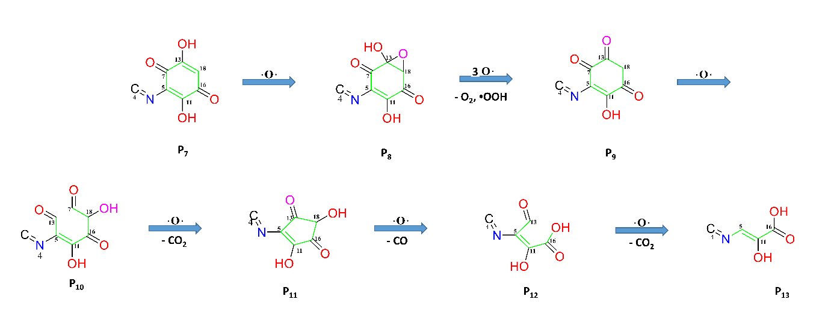
Figure 5. Extended reaction scheme of carbamazepine degradation under cold atmospheric plasma.

During these advanced degradation steps, new C-O-C epoxide-type functionalities appeared (P₈), followed by opening of the remaining aromatic ring (P₁₀) and subsequent formation of a rearranged five-membered cyclic structure (P₁₁). Continued oxidation promoted the release of multi-atomic radical fragments, including species resembling -NH₂ and -CHO groups. These results demonstrate that CBZ degradation involves not only the cleavage of individual bonds but also recanfiguration of complex functional groups and cyclic architectures.
The pronounced decrease in system energy observed during these stages, together with extensive bond rupture and enhanced fragment mobility, accelerates the overall breakdown of the CBZ molecular framework. Collectively, these fragmentation pathways indicate that the system progresses toward advanced degradation and mineralization. In particular, oxidation of carboxyl and amino functionalities, accompanied by the release of CO₂, H₂O, and other low-molecular-weight species, provides molecular-level evidence for the terminal degradation of CBZ. These transformation products are consistent with oxidation species reported in experimental plasma treatment studies, supporting the validity of the proposed reaction pathway. Based on the trajectory analysis, CBZ oxidation in the presence of atomic oxygen can be classified into four main processes: hydroxylation, ring opening and re-closure, fragmentation, and release of small molecules such as CO₂ and H₂O. Despite explicitly considering only atomic oxygen, the simulations reproduce the main experimental product spectrum, highlighting the effectiveness of the DFTB+ approach for elucidating molecular-level mechanisms under plasma conditions.

CONCLUSION
In this study, the oxidation and degradation behavior of carbamazepine under cold atmospheric plasma conditions was investigated using DFTB-based reactive molecular dynamics simulations. By explicitly considering atomic oxygen, our simulations provide a detailed picture of how plasma-generated reactive species initiate and propagate molecular degradation at the atomic scale. The results show that CBZ degradation follows a stepwise but highly dynamic sequence, starting with selective hydrogen abstraction and functionalization reactions such as hydroxylation and epoxidation. As oxygen exposure continues, these early modifications destabilize the aromatic and heterocyclic frameworks, leading to ring opening, intramolecular rearrangement, and eventual fragmentation of the molecular backbone. In several trajectories, transient ring re-closure was observed before further oxidation triggered extensive bond cleavage and release of small molecules, including CO₂ and H₂O, indicating progression toward mineralization. Importantly, the transformation products and degradation trends identified in the simulations are consistent with those reported in experimental plasma treatment studies of CBZ. In our view, this agreement confirms that atomic oxygen plays a central role in directing electrophilic attack at selective sites and validates the proposed reaction pathways. Although the simulations focus on a simplified plasma environment, the observed mechanisms capture the essential features of plasma-driven oxidation. Overall, this work highlights the effectiveness of DFTB-MD as a practical and reliable tool for elucidating complex degradation mechanisms of recalcitrant pharmaceutical compounds under plasma conditions.

REFERENCES
- Wypart-Pawul, A., Neczaj, E., Grosser, A. and Grobelak, A. Assessment of the effectiveness of atmospheric plasma on the removal of selected pharmaceuticals from water. Desalination and Water Treatment, 2024, 320, p.100600. https://doi.org/10.1016/j.dwt.2024.100600
- Wee, S. Y., Aris, A. Z., Yusoff, F. M., & Praveena, S. M. Occurrence of multiclass endocrine disrupting compounds in a drinking water supply system and associated risks. Scientific Reports, 2020, 10(1), 17755.
- Wicht, A. J., Heye, K., Schmidt, A., Oehlmann, J., & Huhn, C. The wastewater micropollutant carbamazepine in insectivorous birds an exposure estimate. Analytical and bioanalytical chemistry, 2022, 414(17), 4909-4917.
- Rayaroth, M. P., Aubry, O., Rabat, H., Marilleau, E., Gru, Y., Hong, D., & Brault, P. Degradation and transformation of carbamazepine in aqueous medium under non-thermal plasma oxidation process. Chemosphere, 2024, 352, 141449. https://doi.org/10.1016/j.chemosphere.2024.141449
- Kyere-Yeboah, K., Bique, I. K., & Qiao, X. C. Advances of non-thermal plasma discharge technology in degrading recalcitrant wastewater pollutants. A comprehensive review. Chemosphere, 2023, 320, 138061. https://doi.org/10.1016/j.chemosphere.2023.138061
- Nabiyeva, N., Akramov, T., Abduvokhidov, D., Zhang, Y., Yusupov, M., & Razzokov, J.. Preliminary study on degradation mechanisms of plasma-treated DR1 by atomistic simulations. Plasma Science and Technology, 2025, 27(3), 035504. DOI 10.1088/2058-6272/ada21e
- Aradi, B., Hourahine, B., & Frauenheim, T. DFTB+, a sparse matrix-based implementation of the DFTB method. The Journal of Physical Chemistry A, 2007, 111(26), 5678-5684.
- Qian, H. J., Van Duin, A. C., Morokuma, K., & Irle, S. Reactive molecular dynamics simulation of fullerene combustion synthesis: ReaxFF vs DFTB potentials. Journal of chemical theory and computation, 2011, 7(7), 2040-2048.
- Gaus, M., Goez, A., & Elstner, M. Parametrization and benchmark of DFTB3 for organic molecules. Journal of Chemical Theory and Computation, 2013, 9(1), 338-354.
- Kubillus, M., Kubar, T., Gaus, M., Rezac, J., & Elstner, M. Parameterization of the DFTB3 method for Br, Ca, Cl, F, I, K, and Na in organic and biological systems. Journal of chemical theory and computation, 2015, 11(1), 332-342.

