HYDROTHERMAL SYNTHESIS OF CARBON DOTS BASED ON GLYCYRRHIZIC ACID AND THIOUREA

Niginabonu Nasimova ¹, Yusufboy Rajabov ², Jaykhun Mamatov ¹, Mohinur Nigmatillayeva ¹, Khamdam Akbarov ¹

¹Faculty of Chemistry, National University of Uzbekistan, Tashkent, 100174, Uzbekistan
² State Security Service of the Republic of Uzbekistan
ORCID: 0000-0002-3373-9181

ABSTRACT
This study describes a hydrothermal method for synthesizing novel carbon dots (CDs) based on glycyrrhizic acid (GLA) and thiourea (TM). Detailed information is provided regarding the optimal ratios and concentrations of the precursors, as well as the specific synthesis duration and temperature parameters. Furthermore, the purification processes and stages employed to isolate the synthesized CDs in their pure form are elucidated.
The synthesized CDs are classified as nanoscale materials, and their particle size distribution was analyzed using Dynamic Light Scattering (DLS). The results indicated a particle size range of 6.9–12.52 nm, confirming the high degree of structural uniformity. The chemical structure of the synthesized CDs was characterized via Fourier-transform infrared (FT-IR) spectroscopy and compared with the spectra of the initial precursors, GLA and TM. The analysis reveals significant chemical transformations of the functional groups present in the starting materials as a result of the reaction, which are clearly reflected in the shifting and emergence of characteristic peaks in the FT-IR spectra.
Keywords: Carbon dots (CDs), Glycyrrhizic acid (GLA), Thiourea (TM), Hydrothermal synthesis, Dynamic Light Scattering (DLS), Fourier-transform infrared spectroscopy (FT-IR).

INTRODUCTION
In recent years, global challenges such as environmental issues, energy resource depletion, and the escalation of industrial waste have reached critical importance. Consequently, developing sustainable, cost-effective, and efficient technologies based on eco-friendly nanomaterials has become a paramount objective from both scientific and practical perspectives. Carbon dots (CDs) represent a new generation of luminescent carbon-based nanomaterials, typically forming ultra-small dispersed systems. Due to their unique chemical composition and superior biological properties, CDs are regarded as a viable and safe alternative to traditional metal-based quantum dots [1]. Owing to their exceptional optical properties, high biocompatibility, and low toxicity, these materials are being extensively investigated in fields such as biosensing, genetic engineering, and targeted drug delivery systems [2,3].
Carbon dots have emerged as a significant alternative to conventional metal-based quantum dots due to their favorable elemental composition and high biocompatibility [4]. CDs, or carbon quantum dots (CQDs), are classified as zero-dimensional (0D) carbon-based nanomaterials with dimensions typically below 100 nm [5]. These materials are organic compounds containing various functional groups, such as –OH, –OR, –NH₂, –NR₂, –NHR, –SR, –SH, –CN, –N=N, –COOH, –CO, –CHO, –CONH₂, and –COOR, which facilitate their widespread application across diverse sectors [6]. The presence of functional groups like –OH, –COOH, and –NH₂ on the surface of CDs renders them water-soluble and highly reactive with various biomolecules [7]. Such properties have expanded their utility in drug delivery, bioimaging, and catalysis. It has been demonstrated that the fluorescent properties of CDs are intrinsically linked to their core structure, surface functionality, and synthesis methodology [8].
Furthermore, CDs find extensive applications in various industrial and biological processes, including catalysis, biomedicine, sensors, energy storage, and optoelectronics [9]. In recent years, they have also gained significant traction as effective corrosion inhibitors [10].

METHODOLOGY
Synthesis of GLA+TM Carbon Dots. The synthesis of carbon dots (CDs) is generally categorized into two strategic approaches: (1) the "top-down" method and (2) the "bottom-up" method. The "top-down" approach involves the fragmentation of large carbonaceous structures into smaller nanoparticles using techniques such as chemical oxidation, arc discharge, electrochemical exfoliation, and ultrasonic treatment [11]. However, the primary disadvantages of this approach include the requirement for expensive raw materials, harsh (aggressive) reaction conditions, and prolonged processing times [12].
In contrast, the "bottom-up" approach is based on the conversion of small-molecule carbon precursors into CDs of the desired dimensions. This strategy encompasses efficient methods such as hydrothermal and solvothermal treatments, thermal decomposition, pyrolysis, carbonization, as well as microwave-assisted and ultrasonic synthesis.
Among these, hydrothermal synthesis is one of the most widely utilized methods for producing carbon dots, typically conducted in sealed reactors (autoclaves) at temperatures ranging from 160°C to 220°C. This method is considered both simple and highly efficient for the carbonization process [13]. In this study, analytical grade reagents were employed to synthesize carbon dots derived from glycyrrhizic acid (GLA) and thiourea (TM) (Figure 1).
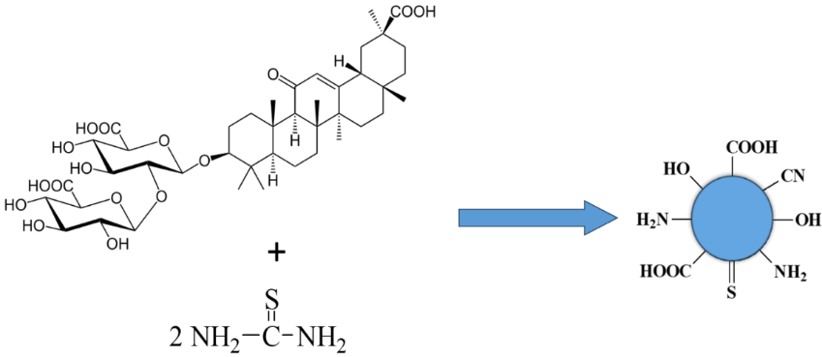
Figure 1. Synthesis reaction of GLA+TM carbon dots.

Dynamic Light Scattering (DLS) Analysis. Dynamic Light Scattering (DLS) is the most widely utilized analytical technique for determining the size of nanoscale particles. The principle of DLS is based on the Brownian motion of dispersed particles. This method is of paramount importance in the analysis of suspensions containing nanoparticles and their aggregates, serving as a critical tool for quality control and the optimization of dispersion conditions [14]. In this study, the particle size of the synthesized carbon dots (CDs) was determined using an NKT-N9 Nano Particle Sizer instrument via the DLS approach [15].
Fourier-Transform Infrared (FT-IR) Spectroscopy. Infrared (FT-IR) spectroscopy is a physical characterization method used to investigate the chemical structure of substances, based on the interaction of their energy spectra with electromagnetic radiation in the infrared region. Typically, analysis is conducted within the spectral range of 4000–400 cm⁻¹. FT-IR spectroscopy is a vital analytical technique for identifying functional groups in organic compounds, often providing high precision in scenarios where Nuclear Magnetic Resonance (NMR) spectroscopy may have limitations. These spectra are recorded as a result of the interaction between infrared electromagnetic waves and molecular structures [16].
The absorption of radiation in the infrared region induces atomic vibrations within the molecules. In the experimental procedure, the FT-IR spectrum of the initial precursor is first recorded as a reference. Subsequently, the FT-IR spectra of the synthesized materials are obtained. By comparing the absorption bands of these spectra, the structural characteristics of the substance and the progression of the chemical reaction can be evaluated. The formation of new absorption maxima, the disappearance of specific bands, or their shifts to different spectral regions indicate the occurrence of a chemical transformation. Furthermore, the use of standard reference databases is instrumental in the accurate interpretation of FT-IR spectra.

RESULTS
To synthesize the GLA+TM carbon dots, 1.644 g of glycyrrhizic acid (0.002 mol) and 0.304 g of thiourea (0.004 mol) were accurately weighed using an analytical balance. The precursors were dissolved in 100 ml of distilled water and stirred at room temperature for 10 minutes. To ensure complete dissolution, the mixture was subjected to ultrasonication for 2 minutes at 20°C. The pH of the solution was then adjusted to a range of 10.2–10.5 using 0.1 N NaOH.
The prepared precursor solution was transferred into a 100 ml teflon-lined stainless steel autoclave and heated at 180°C for 6 hours. Based on the preliminary experimental results, the optimal precursor ratios, reaction time, and temperature were established. This paper reports the results obtained under these optimized conditions.
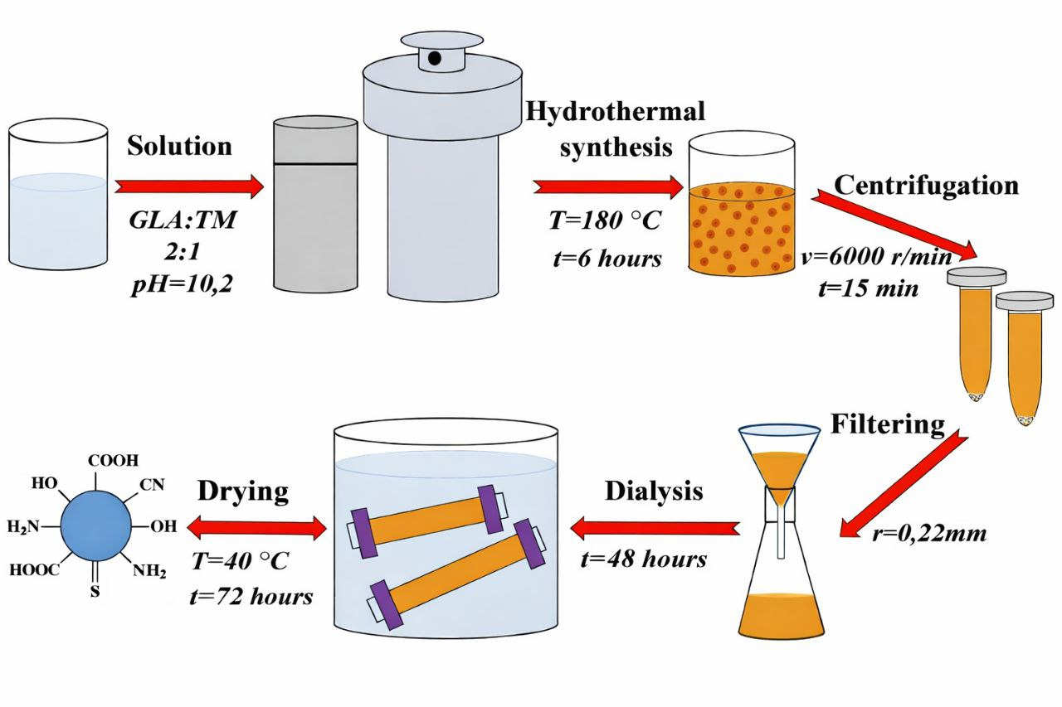
Figure 2. Schematic illustration of the synthesis process of GLA+TM-based carbon dots.

Upon completion of the synthesis, the resulting solution underwent a rigorous purification procedure. Initially, the CD-containing solution was filtered to remove large-scale impurities. To further precipitate any remaining macro-particles, the filtrate was centrifuged at 6000 rpm for 15 minutes, followed by a secondary filtration step. This centrifugation-filtration cycle was repeated twice.
To eliminate small-molecule impurities and unreacted precursors, the filtrate was subjected to dialysis for 48 hours. During this period, the deionized water was replaced every 2 hours initially, and subsequently every 10 hours. The purified CD solution was then dried at a temperature of 40–45 °C for 72 hours (Figure 2).
The particle size and size distribution of the GLA+TM-based carbon dots were characterized using the Dynamic Light Scattering (DLS) method. The obtained DLS distribution curve consists of several fractions, with the predominant portion of particles falling within the 6.9–12.52 nm range (Figure 3). According to the quantitative analysis of the distribution, particles with dimensions of 4.5–6.0 nm account for 28.1% of the total volume, while the majority fraction ranging from 6.0–8.5 nm constitutes 51.3%, and the remaining 20.6% is represented by larger particles in the 8.5–11.0 nm range.

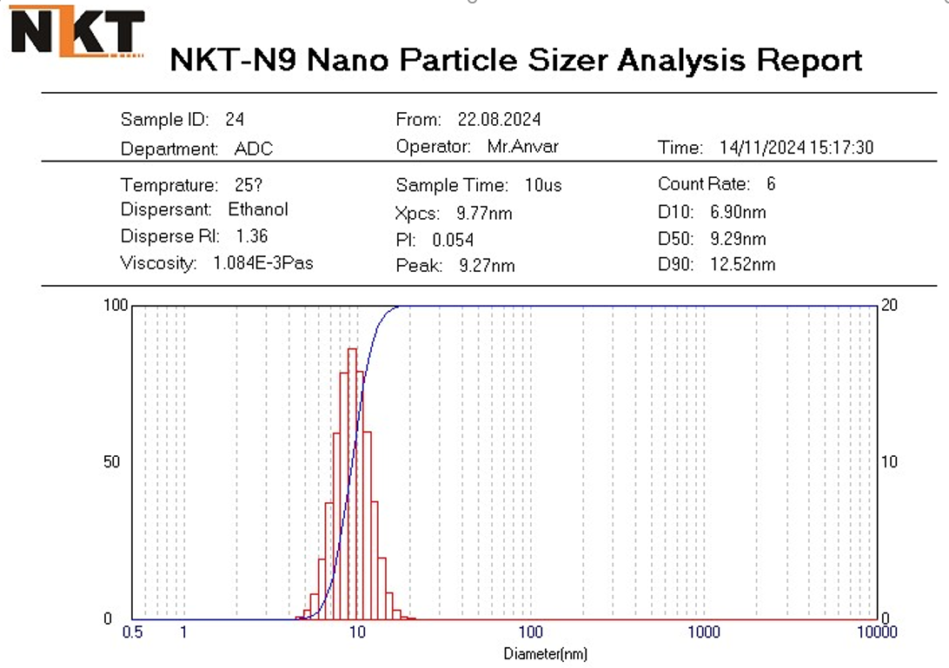
Figure 3. DLS size distribution results of the GLA+TM carbon dots.

The average hydrodynamic diameter of the particles was found to be 8.3 nm, with a polydispersity index (PDI) of 0.214. In DLS analysis, this indicates a low degree of dispersion characteristic of a monodisperse system. Systems with a PDI ranging from 0.1 to 0.3 are generally evaluated as well-dispersed, non-aggregated, and kinetically stable within the dispersion medium.
The primary peak of the DLS spectrum is centered at 9.27 nm, representing the most frequently occurring particle diameter. The intensity curve is sharp and well-centered, confirming the uniformity of the particles and the stable control of the synthetic process. Intermolecular hydrogen bonding or remaining functional groups affecting the hydrodynamic radius are indirectly detected via DLS; the results demonstrate that the novel material possesses a stable colloidal structure [17].
According to the FT-IR spectroscopy results, the spectrum of glycyrrhizic acid (GLA) exhibited a broad and intense peak at 3380 cm⁻¹, corresponding to the O–H stretching vibrations involved in hydrogen bonding (Figure 4). A distinct stretching vibration peak for the C=O (carboxyl) group was identified at 1720 cm⁻¹, while a signal characteristic of aromatic C=C vibrations was observed at 1620 cm⁻¹. Additionally, C–O bond vibrations were recorded at 1048 cm⁻¹.
In the thiourea (TM) spectrum, N–H stretching vibrations were identified at 3265 cm⁻¹, along with a stretching vibration signal characteristic of the C=N group at 1608 cm⁻¹ and a C=S bond vibration peak at 1252 cm⁻¹.
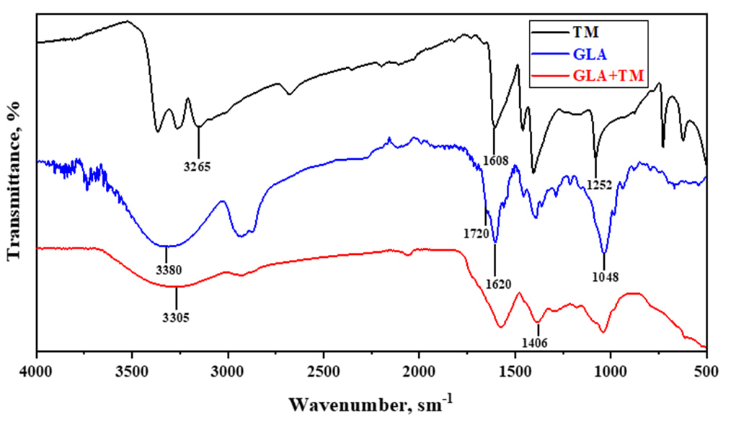
Figure 4. FT-IR spectrum of the GLA+TM carbon dots.

The FT-IR spectrum of the synthesized GLA+TM carbon dots reveals significant structural transformations compared to the initial precursors. The O–H stretching vibration is maintained at 3305 cm⁻¹, while the C=O stretching vibration shifted to a lower wavenumber of 1705 cm⁻¹ compared to glycyrrhizic acid, indicating a change in the chemical environment. Notably, the characteristic peak for the C=S bond at 1252 cm⁻¹ in thiourea completely disappeared, suggesting that this bond participated in the reaction.
Instead, a new signal emerged around 1406 cm⁻¹, which can be attributed to the formation of C–N or C–S bonds. Furthermore, the intensity of the C=N signal decreased and exhibited a red shift to 1595 cm⁻¹. These observations collectively confirm that the functional groups of the starting materials underwent significant interaction during the synthesis, resulting in the formation of new functional groups, particularly those involving sulfur (S) and nitrogen (N) heteroatoms.

CONCLUSIONS
In this study, nitrogen and sulfur-doped carbon dots (N,S-CDs) were successfully synthesized via a one-step hydrothermal method using glycyrrhizic acid (GLA) and thiourea (TM) as precursors. The synthesis was conducted under alkaline conditions (pH 10.2–10.5) at a temperature of 180°C for 6 hours, yielding nanomaterials with exceptional colloidal stability.
Dynamic Light Scattering (DLS) analysis demonstrated that the synthesized CDs exhibit a narrow size distribution. The majority of the particles (51.3%) fall within the range of 6.0–8.5 nm, with an average hydrodynamic diameter of 8.3 nm. The polydispersity index (PDI) value of 0.214 confirms the monodisperse nature of the system, indicating that the particles are well-dispersed without aggregation and are kinetically stable within the dispersion medium.
FT-IR spectroscopic analysis verified the chemical interaction between the precursors and the successful incorporation of heteroatoms into the carbon framework. The disappearance of the characteristic C=S bond (1252 cm⁻¹ ) from thiourea and the emergence of new signals at 1406 cm⁻¹ (C–N/C–S) and 1595 cm⁻¹ (C=N) indicate the effective doping of nitrogen and sulfur into the CD structure. Furthermore, the shift of the carboxyl C=O stretching vibration from 1720 cm⁻¹ to 1705 cm⁻¹confirms the formation of a new chemical environment resulting from the synergistic interaction between GLA and TM.
The obtained GLA+TM-based carbon dots, characterized by their uniform size distribution, rich functional groups, and high stability, hold immense potential for applications in biosensing, bioimaging, and targeted drug delivery systems. This research presents a sustainable and "green" strategy for the fabrication of high-performance heteroatom-doped carbon nanomaterials from natural raw materials.

REFERENCES
- Tuerhong M., Yang X. U., Xue-Bo Y. I. N. Review on carbon dots and their applications // Chinese Journal of Analytical Chemistry. – 2017. – Т. 45. – №. 1. – С. 139-150.
- Wang H. et al. Biocompatible PEG‐chitosan@ carbon dots hybrid nanogels // Advanced Functional Materials. – 2015. – Т. 25. – №. 34. – С. 5537-5547.
- Kong B., Zhu A., Ding C., Zhao M., Li B., Tian Y. Carbon dot-based ratiometric fluorescent sensor for sensitive and selective detection of mercury (II) ions // Biosensors and Bioelectronics. – 2011. – Т. 30. – №. 1. – С. 14-19.
- Baker S. N., Baker G. A. Luminescent carbon nanodots: emergent nanolights //Angewandte Chemie International Edition. – 2010. – Т. 49. – №. 38. – С. 6726-6744.
- Wang Q. et al. Carbon dots: synthesis, properties and applications // Journal of Materials Chemistry C. – 2014. – Т. 2. – №. 34. – С. 6921-6939.
- Berdimurodov E. et al. The recent development of carbon dots as powerful green corrosion inhibitors: A prospective review //Journal of Molecular Liquids. – 2022. – Т. 349. – С. 118124.
- Hola K. et al. Carbon dots–Emerging light emitters for bioimaging, cancer therapy and optoelectronics // Nano Today. – 2014. – Т. 9. – №. 5. – С. 590-603
- Li H., Kang Z., Liu Y., Lee S.T. Carbon nanodots: synthesis, properties and applications. Journal of Materials Chemistry, 2012, 22(46): 24230–24253.
- Wang Y., Hu A. Carbon quantum dots: synthesis, properties and applications // Journal of Materials Chemistry C. – 2014. – Т. 2. – №. 34. – С. 6921-6939.
- Saraswat V., Yadav M. Carbon dots as green corrosion inhibitor for mild steel in HCl solution // ChemistrySelect. – 2020. – Т. 5. – №. 25. – С. 7347-7357.
- Lim S. Y., Shen W., Gao Z. Carbon quantum dots and their applications //Chemical Society Reviews. – 2015. – Т. 44. – №. 1. – С. 362-381.
- Wang Y., Kalytchuk S., Zhang Y. et al. Brightening the performance of carbon dot by selective chemical functionalization. Chem. Commun., 2015, 51(15): 2964–2967.
- Wang Y., Hu A. Carbon quantum dots: synthesis, properties and applications //Journal of Materials Chemistry C. – 2014. – Т. 2. – №. 34. – С. 6921-6939.
- Babick F. Dynamic light scattering (DLS) //Characterization of nanoparticles. – Elsevier, 2020. – С. 137-172.
- Huo X. et al. Solvent effects on fluorescence properties of carbon dots: implications for multicolor imaging //ACS omega. – 2021. – Т. 6. – №. 40. – С. 26499-26508.
- Punjabi D. et al. Infrared spectrum analysis of organic molecules with neural networks using standard reference data sets in combination with real-world data //Journal of Cheminformatics. – 2025. – Т. 17. – №. 1. – С. 1-13.
- Zhu S., Meng Q., Wang L. et al. Highly photoluminescent carbon dots for multicolor patterning, sensors, and bioimaging. Angew. Chem. Int. Ed., 2013, 52(14): 3953–3957.

