DETERMINATION OF COPPER (II) IONS USING 5-(O-AMINOPHENYL)-1,3,4-OXADIAZOLE-2-THIONE REAGENT BY ELECTROCHEMICAL METHODS
Davron Kuronboyev¹, Nigora Qutlimurotova², Jayhun Mamatov¹, Husan Yaxshinorov¹,
Shukhrat Samandarov³
¹Department of Physical chemistry, National University of Uzbekistan, Tashkent, 100034, Uzbekistan
²Department of Analytical chemistry, National University of Uzbekistan, Tashkent, 100034, Uzbekistan
³Department of Natural Sciences, University of Business and Science
ORCID: 0009-0006-4029-3268
ABSTRACT
The possibilities of highly sensitive and selective electrochemical determination of copper(II) ions using the organic reagent 5-(o-aminophenyl)-1,3,4-oxadiazole-2-thione (HR₁) were studied. Chronoamperometry and cyclic voltammetry were employed to analyze the kinetics and mechanism of the process. The obtained results showed that the reduction of the reagent on the electrode surface was observed at 0.93 V, while the shift of the potential to 0.52 V after the addition of copper(II) ions confirmed the formation of a complex. Based on the cyclic voltammetry and chronoamperometry results, the involvement of two electrons in the reaction calculated. The developed method exhibited a linear relationship in the concentration range of 1.12 to 9.40 μg/mL for copper(II) ions. The results obtained by the "spiked-found" method (R = 0.9948; Sr = 0.013–0.067) confirm the high accuracy, repeatability, and reliability of the method. Due to its low cost, simple preparation, no requirement for expensive laboratory equipment, and rapid analysis, the proposed method is considered as promising for wide application in the ecological and toxicological monitoring of copper(II) ions in soil, food, and biological samples.
Keywords: 5-(o-aminophenyl)-1,3,4-oxadiazole-2-thione, chronoamperometry, cyclic voltammetry, electrochemical sensor, complex formation, environmental monitoring.

- INTRODUCTION.
Copper is one of the most widely used non-ferrous metals in the world. Due to its high thermal and electrical conductivity, corrosion resistance, and ease of processing, it is extensively used in electrical engineering, construction, mechanical engineering, and daily life. At the same time, copper is an important biogenic element: it is present in small amounts in the bodies of humans, animals, and plants, and participates in hematopoiesis (blood formation), enzyme activity, and cellular respiration. However, the biological significance of copper is strictly dependent on its concentration. Exceeding the permissible limit of Cu²⁺ ions in the organism leads to poisoning. The toxic effects of copper manifest as oxidative stress, damage to cell membranes, and impairment of liver and kidney function. Due to the danger of excessive amounts of copper ions, the Environmental Protection Agency (EPA) has set the maximum allowable concentration of Cu²⁺ in drinking water at 20 μM [1, 2]. The World Health Organization (WHO) has also determined that the maximum allowable concentration of copper in blood is 100–150 μg/dL [3]. Consequently, developing a highly sensitive and selective approach for the determination of Cu²⁺ is crucial for health and environmental monitoring. Therefore, the determination of trace amounts of copper(II) ions in environmental objects (water, soil, food products) is one of the important tasks of ecological and toxicological monitoring. It is this balance between a necessary micronutrient and a dangerous toxicant that makes the study of copper not only interesting but also vitally important.
Among the modern methods used in recent years for the determination of copper(II) ions, a colorimetric method [4] utilizing an enzoxazole-spiropyran derivative has been reported. When this derivative interacts with Cu²⁺, the colorless solution changes to a red-wine color, and complex formation occurs with almost no interference from other ions. The limit of detection was found to be 10⁻⁷ M (0.1 µM). Reference [5] presents data on a fluorescence method using carbon dots (CDs). Upon complexation of iCDs with Cu²⁺, a loss of their fluorescence property was observed. In turn-off sensors, an increase in Cu²⁺ concentration led to a decrease in fluorescence intensity. The magnetic nanocomposites (Fe₃O₄/CD@SiO₂-QD) used in that study not only allowed the determination of copper(II) ions but also their removal from the solution. The limit of detection for Cu(II) ions was found to be 0.23 µM.
Currently, traditional methods for the determination of Cu²⁺ are mainly based on inductively coupled plasma optical emission spectroscopy (ICP-OES) [6], inductively coupled plasma mass spectrometry (ICP-MS) [7], atomic absorption spectroscopy (AAS) [8], potentiometry [9], and atomic emission spectrometry [10]. However, although these methods ensure the accuracy and reliability of the data, they are complex, time-consuming, and require expensive instruments [11–13]. Therefore, electrochemical methods are also widely used by many researchers. In [14], the authors developed a DNA-aptamer + magnetic nanoparticle sensor. Using the obtained Fe₃O₄@Au + DNA material for environmental monitoring of copper ions, the limit of detection was found to be 0.4 pM. Reference [15] is dedicated to food analysis, while the authors of [16] applied their sensors to plant samples, and [17] to biological and ecological improvements. Electrochemical methods, including cyclic voltammetry and chronoamperometry, are characterized by high sensitivity and reliability of analytical results for the determination of metal ions [18]. Using these methods, [19] conducted protein research, while [20] synthesized a chalcogenide glassy-crystalline Cu-As-S electrode and evaluated its selectivity and sensitivity toward copper(II) ions using electrochemical impedance spectroscopy. The literature shows that the use of heteroatom-containing reagents in the determination of copper(II) ions increases the sensitivity of the developed method.
In this article, we conducted electrochemical studies of Cu(II) ions using the reagent 5-(o-aminophenyl)-1,3,4-oxadiazole-2-thione. For this purpose, cyclic voltammetry and chronoamperometry, which are cost-effective, efficient, and highly accurate methods, were employed.
2. MATERIALS AND METHODS
2.1. MATERIALS
Preparation of copper(II) ion standard solution: To prepare a 1·10⁻³ M solution of copper(II) ions in this research work, 0.0182 g of dark green crystalline Cu(CH₃COO)₂ salt was taken and placed into a 100 mL volumetric flask, then dissolved in bidistilled water. The flask was filled to the mark with bidistilled water, mixed, and standardized.
Preparation of 5-(o-aminophenyl)-1,3,4-oxadiazole-2-thione standard solution: 0.0193 g (0.001 M) of 5-(o-aminophenyl)-1,3,4-oxadiazole-2-thione was taken and placed into a 100 mL volumetric flask, and the solution was prepared by dissolving it in acetone.
Figure 1. Structural formula of 5-(o-aminophenyl)-1,3,4-oxadiazole-2-thione.

5-(o-Aminophenyl)-1,3,4-oxadiazole-2-thione is a heterocyclic organic compound with the chemical formula C₈H₇N₃OS. It is a crystalline solid that melts at 155–157 °C. It has low solubility in water but is soluble in polar organic solvents such as ethanol, acetone, DMSO, and similar solvents, Rf = 0.45. Its molecular mass is 193.23, and its CAS number is 32058-76-7. The purity of the reagent was determined by thin-layer chromatography [21, 22].
2.2. METHODS
Chronoamperometry is based on the qualitative and quantitative analysis of a substance through the dependence of current changes on time [23,24]. This analysis was performed using a CS-350 digital potentiostat/galvanostat with two platinum electrodes and an AgCl||Ag reference electrode. The electrochemical properties of 5-(o-aminophenyl)-1,3,4-oxadiazole-2-thione were studied by chronoamperometric method in various background electrolytes such as ethanol, acetic acid, DMF, and butanol media.
Cyclic voltammetry detailed information about the kinetics and thermodynamics of many chemical systems can be obtained using cyclic voltammetry, which is one of the electrochemical research methods [25]. 5-(o-Aminophenyl)-1,3,4-oxadiazole-2-thione is a compound capable of forming complexes with metal ions. In this work, the complex formation process between copper(II) ions and the reagent 5-(o-aminophenyl)-1,3,4-oxadiazole-2-thione was studied using cyclic voltammetry. Cyclic voltammetry is considered one of the powerful analytical methods that allows studying the dynamics and mechanism of electrochemical processes.
3. RESULTS AND DISCUSSION
3.1 CHRONOAMPEROMETRIC METHOD
In chronoamperometry, the dependence of potential (E) and current (I) on time (T) is important for understanding the dynamics of the process. The relationship between them shows the following aspects: the change in potential (E) indicates how quickly the reaction is occurring on the electrode surface. The change in current is related to the oxidation or reduction of ions at the electrode depending on the potential. The reagent 5-(o-aminophenyl)-1,3,4-oxadiazole-2-thione and ethanol were placed into a 50.00 mL cell, three electrodes were immersed, and the solution was stirred at 400 rpm. Then, the stirring was stopped, and the dependence of current on time was studied while applying a voltage in the range of 0.1–1.2 V to the electrode. The possibility of determining copper(II) ions with 0.1% (19.3 μg/L) of 5-(o-aminophenyl)-1,3,4-oxadiazole-2-thione reagent was studied by chronoamperometric method, in which the time dependence of the complex formation process between metal ions and the organic reagent is determined. The analysis is performed through the curves of the dependence of time on voltage (I, V) or on the current density at the electrode surface (I, A/cm²)(Figure 2).

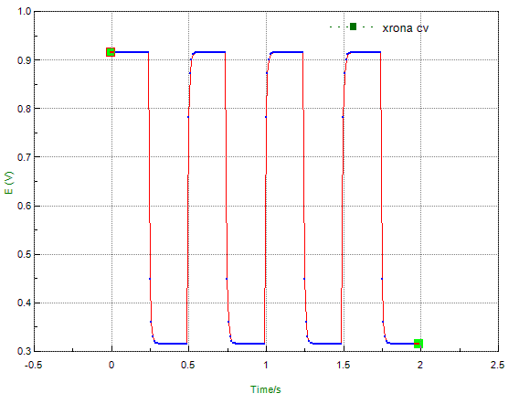 | 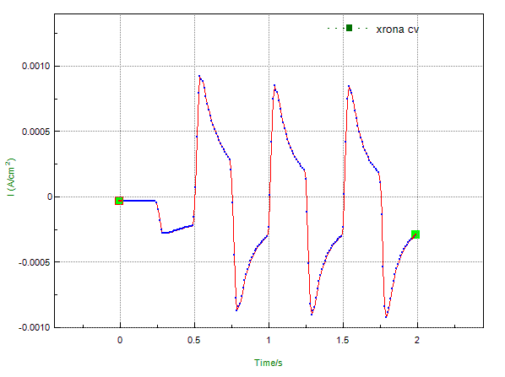
Figure 2. Chronoamperograms of the 5-(o-aminophenyl)-1,3,4-oxadiazole-2-thione reagent: on the left – dependence of voltage on time; on the right – dependence of current on time.

As can be seen from the obtained chronoamperograms, the reductive electrochemical interaction of the 5-(o-aminophenyl)-1,3,4-oxadiazole-2-thione reagent on the working electrode surface was observed at 0.93 V (or 0.00026 A/cm²). When the voltage was changed, reduction occurred within a very short time, and upon further voltage change, it can be observed that the reagent molecules overcome diffusion at a voltage of 0.32 V (or a current of 0.009–0.003 A/cm²) and interact again with the electrode surface through reductive electrochemical interaction. The study was also carried out on a solution of the 5-(o-aminophenyl)-1,3,4-oxadiazole-2-thione reagent in ethanol together with copper(II) acetate, and the results are presented in Figure 3.
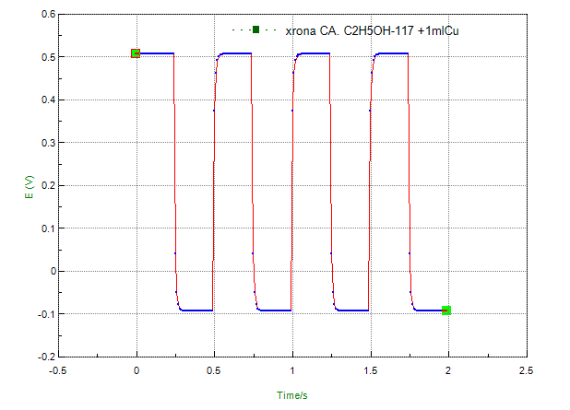 | 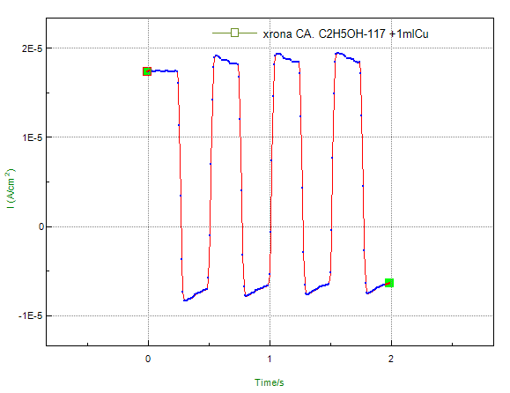
Figure 3. Chronoamperograms for the solution of the 5-(o-aminophenyl)-1,3,4-oxadiazole-2-thione reagent with copper: on the left – dependence of voltage on time; on the right – dependence of current on time

It can be seen that the chronoamperograms obtained for the solution of the 5-(o-aminophenyl)-1,3,4-oxadiazole-2-thione reagent with copper(II) ions differ significantly from the chronoamperograms of the initial 5-(o-aminophenyl)-1,3,4-oxadiazole-2-thione reagent, i.e., a strong shift in potential is observed. The shift of the potential from 0.93 V to 0.52 V indicates the formation of a complex between the reagent and copper ions.
3.2. CYCLIC VOLTAMMETRIC METHOD
In this work, the complex formation process between copper(II) ions and the reagent 5-(o-aminophenyl)-1,3,4-oxadiazole-2-thione was studied using cyclic voltammetry. Cyclic voltammetry allows studying the dynamics and mechanism of electrochemical processes. A solution of the 5-(o-aminophenyl)-1,3,4-oxadiazole-2-thione reagent and copper(II) ions was prepared. Ethanol was chosen as the solvent, and the measurement results are presented in Figure 4.

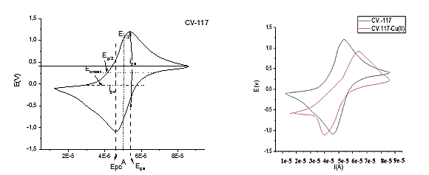
Figure 4(a). CV of a solution of 5-(o-aminophenyl)-1,3,4-oxadiazole-2-thione reagent in ethanol at 50 mV/s. | Figure 4(b). CV of a solution of 5-(o-aminophenyl)-1,3,4-oxadiazole-2-thione reagent in ethanol after the addition of Cu(II) ions at 50 mV/s.
The results of the complex formed between the 5-(o-aminophenyl)-1,3,4-oxadiazole-2-thione reagent and Cu(II) ions are presented. Calculations showed that ethanol provides the optimal conditions for complex formation, with two electrons participating in the reaction.
Table 1
Results of the complex of 5-(o-aminophenyl)-1,3,4-oxadiazole-2-thione reagent with copper(II) ions in ethanol medium at a scan rate of 50 mV/s

Substance | E_{p}, _{a}  _{V} | E_{p}, _{c}  _{V} | E_{p}·10³,  V | E_{1/2},  v | I_{p}, _{a},  А | I_{p}, _{с},  А
ethanol | 0.318 | 0.355 | 0.05  *10³ | 9,39  *10⁻³ | 9.3  *10⁻⁶ | 9,4  *10⁻⁶

This was calculated using the Cottrell equation, which describes the behavior of electrons from copper(II) ions.
Effect of copper(II) ion concentration on the analytical signal
In the developed chronoamperometric method, the dependence of copper(II) ion concentration on current was found to be linear, and the error was determined. To study the effect on the chronoamperogram curve, using the optimal conditions obtained in the previous analysis, 1.0 mL of 5-(o-aminophenyl)-1,3,4-oxadiazole-2-thione reagent and varying amounts of Cu²⁺ ions were added, and the volume was made up to 50 mL with ethanol. The three electrodes were then immersed, and the analysis was performed. The results are presented in Figure 5.

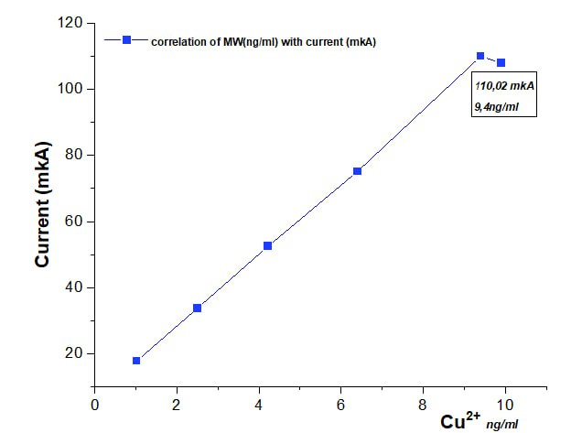
Figure 5. Graph of the dependence of copper(II) ion concentration on the analytical signal

Based on the results of the chronoamperogram presented in Figure 5, a linear relationship between the Cu²⁺ concentration and the analytical signal was observed in the range of 1.12–9.40 μg/mL, while deviations occurred at higher concentrations. This is related to the correlation laws between molecular weight and diffusion coefficients (D) in certain solvents.
Table 2
Evaluation of the accuracy of the chronoamperometric method for the determination of copper(II) ions using the 5-(o-aminophenyl)-1,3,4-oxadiazole-2-thione reagent (n=3)
Added, Cu (μg/ml) | I, mkA | Found, μg/ml±ΔХ | S | Sr
1.12 | 17.75 | 1.12±0,17 | 0,075 | 0,067
2.60 | 31.77 | 2.59±0,23 | 0.123 | 0,048
4.22 | 56.50 | 4.21±0,29 | 0,156 | 0,037
6.40 | 75.18 | 6.39±0,36 | 0,195 | 0,030
9,40 | 110.02 | 9,39±0,22 | 0,121 | 0,013
To verify the accuracy of the developed method, the "spiked–found" method was applied based on the voltammogram values obtained from the chronoamperometric method using the 5-(o-aminophenyl)-1,3,4-oxadiazole-2-thione reagent. The errors were determined, and the correlation coefficient was calculated. The obtained results are presented in table 2
For copper(II) ions in the concentration range of 1.12 μg/mL to 9.40 μg/mL, the correlation coefficient (R) of the dependence on the analytical signal was found to be 0.9948. The proximity of this value to 1 indicates the accuracy of the developed method.
4. CONCLUSION
A method has been developed that allows the determination of copper(II) ions with high sensitivity and selectivity. The reagent 5-(o-aminophenyl)-1,3,4-oxadiazole-2-thione forms a stable complex with copper(II) ions. This interaction was analyzed using cyclic voltammetry and chronoamperometry. The developed method can determine copper(II) ions with a linear relationship in the concentration range of 1.12 to 9.40 μg/mL. The results obtained by the "spiked–found" method (correlation coefficient R = 0.9948) confirm the high accuracy and repeatability of the method. The errors (Sr = 0.013–0.067) and standard deviations (S = 0.075–0.195) demonstrate the reliability of the method. The proposed method has the following advantages: it is inexpensive and easy to prepare; compared to traditional methods (ICP-OES, AAS), it does not require expensive equipment; it offers fast and simple analysis; it is considered promising for monitoring copper(II) ions in water, soil, food, and biological samples.
REFERENCES
- Zheng X. et al. A carbon‐dot‐based fluorescent probe for the sensitive and selective detection of Copper (II) Ions //ChemistrySelect. – 2019. – Т. 4. – №. 8. – С. 2392-2397.
- Stern B. R. Essentiality and toxicity in copper health risk assessment: overview, update and regulatory considerations //Journal of Toxicology and Environmental Health, Part A. – 2010. – Т. 73. – №. 2-3. – С. 114-127.
- Zheng S. et al. Colorimetric/fluorescent/SERS triple-channel sensing of Cu2+ in real systems based on chelation-triggered self-aggregation //Chemical Engineering Journal. – 2020. – Т. 399. – С. 125840.
- 4.Miao W. et al. A spiropyran-based colorimetric probe for the highly selective and sensitive detection of copper (ii) ions //Chemical Communications. – 2026. – Т. 62. – №. 1. – С. 235-238.
- 张长胜 et al. 碳量子点的制备及其在铜离子荧光检测中的应用研究进展 //分析测试学报. – 2025. – T. 44. – No. 4. – pp. 749-758.
- Bruzzoniti M. C. et al. Determination of copper in liquid and solid insulation for large electrical equipment by ICP-OES. Application to copper contamination assessment in power transformers //Talanta. – 2012. – Т. 99. – С. 703-711.
- Townsend A. T. et al. The determination of copper, zinc, cadmium and lead in urine by high resolution ICP-MS //Journal of Analytical Atomic Spectrometry. – 1998. – Т. 13. – №. 11. – С. 1213-1219.
- Chen J., Teo K. C. Determination of cadmium, copper, lead and zinc in water samples by flame atomic absorption spectrometry after cloud point extraction //Analytica Chimica Acta. – 2001. – Т. 450. – №. 1-2. – С. 215-222.
- Ya V. et al. Efficient Cu removal from CuEDTA complex-containing wastewater using electrochemically controlled sacrificial iron anode //Chemosphere. – 2021. – Т. 264. – С. 128573.
- Yuan H. et al. Temporal resolved atomic emission spectroscopy on a pulsed electrolyte cathode discharge for improving the detection sensitivity of Cu //Spectrochimica Acta Part B: Atomic Spectroscopy. – 2021. – Т. 177. – С. 106072.
- Vedamalai M. et al. Carbon nanodots prepared from o-phenylenediamine for sensing of Cu 2+ ions in cells //Nanoscale. – 2014. – Т. 6. – №. 21. – С. 13119-13125.
- Sivaraman G. et al. Chemically diverse small molecule fluorescent chemosensors for copper ion //Coordination Chemistry Reviews. – 2018. – Т. 357. – С. 50-104.
- Chopra T. et al. A comprehensive review on recent advances in copper sensors //Coordination Chemistry Reviews. – 2022. – Т. 470. – С. 214704.
- Meng H. et al. An electrochemical biosensor for detection of copper (ii) based on Fe 3 O 4@ Au magnetic nanoparticles and Cu 2+-dependent DNAzyme assisted nicking endonuclease signal amplification //Analyst. – 2025. – Т. 150. – №. 19. – С. 4436-4442
- Shao J. et al. Ultrasensitive homogeneous electrochemiluminescence biosensor based on DNAzyme walker-regulated interface reaction rates strategy for one-step quantification of copper ions //Food Chemistry. – 2025. – С. 147003.
- Li J. et al. MOF-Derived N-Doped Carbon Nanotube-Confined Ni Nanoparticles for the Simultaneous Electrochemical Detection of Cu²⁺ and Hg²⁺ with High Sensitivity and Stability //Molecules. – 2025. – Т. 30. – №. 5. – С. 1078.
- Ashenagar A., Tarighat M. A., Abdi G. Development of highly selective and sensitive electrochemical sensor for trace level determination of Cu2+ ions in different biological and Persian Gulf Algae samples //Sensing and Bio-Sensing Research. – 2025. – Т. 47. – С. 100762.
- Flores E. et al. An electrochemical sensor for the determination of Cu (II) using a modified electrode with ferrocenyl crown ether compound by square wave anodic stripping voltammetry //Sensors and Actuators B: Chemical. – 2017. – Т. 251. – С. 433-439.
- Pilz F. H., Kielb P. Cyclic voltammetry, square wave voltammetry or electrochemical impedance spectroscopy? Interrogating electrochemical approaches for the determination of electron transfer rates of immobilized redox proteins //BBA advances. – 2023. – Т. 4. – С. 100095.
- Cali C. et al. Copper (II) selective electrode based on chalcogenide materials: study of the membrane/solution interface with electrochemical impedance spectroscopy and X-ray photoelectron spectroscopy //Materials Science and Engineering: C. – 2002. – Т. 21. – №. 1-2. – С. 3-8.
- Holla B. S., Kalluraya B., Nath S. C. Synthesis, characterization, spectral and antifungal properties of some 5‐Substituted‐1, 3, 4‐oxadiazole‐2‐thiones and their mannich bases //Journal für Praktische Chemie. – 1988. – Т. 330. – №. 4. – С. 549-557.
- D. Ismailova, A. Ziyaev, B. Elmurodov, T. Toshmurodov, K. Bobaqulov, R. Zokirova, 2-alkiltio-5-(p-aminofenil)-1, 3 ningmaqsadli sintezi va in vitro bakteritsid va fungitsid faoliyati. 4-oksadiazollar., J. Basic Appl. Res. Biomed. 2 (2016) 476–479.
- Gomez H., Riveros G., Ramirez D. Chronoamperometric Cu (II) Analysis at Gold Ultramicroelectrodes in Concentrated Sulfuric Acid Solutions //International Journal of Electrochemical Science. – 2017. – Т. 12. – №. 2. – С. 985-993.
- Uka B. et al. Chronoamperometric detection of heavy metal ions for multi-analyte water analysis with microsensors //2022 IEEE Sensors. – IEEE, 2022. – С. 1-4.
- Liv L., Tosun S. G., Özerdem Z. Sunset Yellow-Cu (II) Complex: DFT-supported electrochemical investigation and determination of Cu (II) ions in human serum and artificial sweat //Microchemical Journal. – 2025. – Т. 208. – С. 112441.

